National University of Ireland, Maynooth
DEPARTMENT OF HISTORY

FLYERS FOR OPTIONAL MODULES

II ARTS SEMESTER 2 2023-24

PLEASE NOTE

Flyers provide information supplementary to that available in module descriptors, which may be viewed on the university database at www.maynoothuniversity.ie/courses.

Students are expected to consult both flyers and module descriptors, as well as the academic timetable, in advance of registration.

national university of ireland, maynooth
department of history
second arts, 2023-24
Second Semester
Module Co-ordinator  DR MICHAEL POTTERTON | Module code  HY 224 | Credits  5 | Lecture hours per week  Two

Module title:
SETTLEMENT AND SOCIETY IN IRELAND

Module content
Ireland boasts one of the most abundant archaeological and historical landscapes in the world. It is especially rich and varied for the Middle Ages – from the advent of Christianity in the fifth century to the dissolution of the monasteries over a millennium later in the 1530s and 1540s. The fifth century also marks the beginning of writing in Ireland and the start of our documented history. Combining the evidence of written sources with what we know from archaeology and the visible physical remains of the past we can recreate a vivid picture of life in medieval Ireland. We can start to understand, for example, where and how people lived, what their daily lives were like, what they ate and drank, how society was structured, how they practised religion, how they dealt with death, and much more.

Module aim
The core aim of this module is to familiarise students with aspects of settlement and society across the island of Ireland from the beginning of recorded history in the early medieval period to the end of the Middle Ages. Illustrated lectures will guide participants on a virtual tour of the sites, monuments and landscapes of medieval Ireland. Using specific examples, we will examine when, why and how they were constructed, who was responsible, what it was like to live, work and die during that time and what significance this has in the twenty-first century. Upon successful completion of the module, students will
- be familiar with major developments in Ireland in the period c.AD400–1600;
- be aware of where and how people lived during this time;
- be able to recognise Irish medieval archaeological monuments and landscapes;
- understand the significance of the medieval past in the modern world.
Form of assessment
There are three parts to the assessment for this module:
a. one in-class test (25% of module marks)
b. one illustrated project (3,000 words), due 13 May 2024 (65% of module marks)
c. participation in class (10% of module marks)

Special requirements
Some of the classes will take place at medieval sites in and near Maynooth. There will also be one Saturday field trip; we will travel via coach from Maynooth and visit a number of sites in north Leinster. The trip will cost students €20 each. All participants in the module are expected to attend all classes and the field trip. Further details will be provided in class and on Moodle.
national university of ireland, maynooth
department of history
second arts, 2023-24

Second Semester
Lecturer  DR DYMPNA MC LOUGHLIN | Module code HY 230 | Credits  5 | Lecture hours per week  Two

Module title
HISTORY OF HEALTH AND MEDICINE A

Overview

This module introduces the history of medicine. The following themes will be covered:
- the structure and function of the medical profession, including doctors, surgeons, and apothecaries.
- Quack and quackery.
- The professionalization of nursing.
- the main medical institutions of the nineteenth century, including the hospital
- the dispensary- a local model of healthcare.
- the adulteration of food and its consequences on human health
- the complex issue of mental health and the treatment of the vulnerable in asylums.
- Tuberculosis and its impact of the stigma of tuberculosis on sufferers and their family in twentieth century Ireland.
- The Contagious Diseases Acts and the feminisation of venereal disease.
- Eugenics.

Aim
The aim of this module is to introduce students to the developing area of medical history

Form of Assessment

Two-hour end of semester examination

national university of ireland, maynooth
department of history
second arts, 2023-24
Second Semester
Lecturer  DR DAVID LEDERER | Module code HY 249 | Credits  5 | Lecture hours per week  Two

Module title
THE HISTORY OF SUICIDE: A GLOBAL OUTLOOK

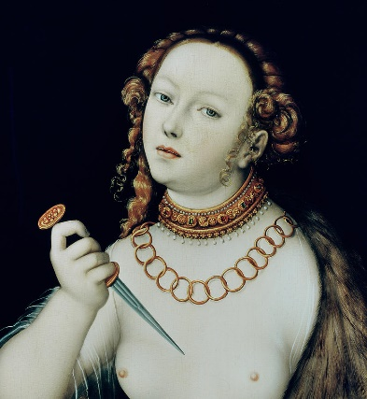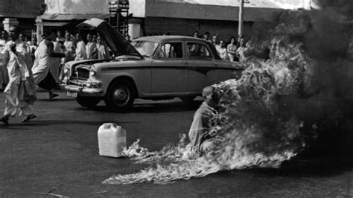

Module content

Ironically, before 1993, suicide was a crime in Ireland. However, across the centuries and throughout cultures, voluntary death has been perceived differently. In classical antiquity, Lucretia’s death was interpreted as a defence of her virtue. In 1963, Qang Duc, a buddhist monk, self-immolated to protest the Vietnam regime. The Bushido code reserved seppuku for the samurai class, but it was re-defined when young Japanese pilots were coerced into kamikaze service during the Second World War. Since Emile Durkheim published Le Suicide (1897), sociologists argued that voluntary death is a soluble social problem. Enlightened physicians declared it an act of insanity; today, physicians struggle with the challenge of euthanasia.

Over the course of the semester, we will consider the value of cultural history as a tool for understanding this global social phenomenon. Students participate actively in a series of in-class discussions, presentations of historical documents and oral book reviews, posting to a group website and composing an essay for submission at the end of the semester.

Form of assessment

3,000 word essay 60%
In-class assignments/tests 40%
Deadline for submission of essay is: Monday, 13 May 2024
national university of ireland, maynooth
department of history
second arts, 2023-24
Second Semester
Lecturer  PROFESSOR MARIAN LYONS | Module code  HY 283 | Credits  5 | Lecture hours per week  Two

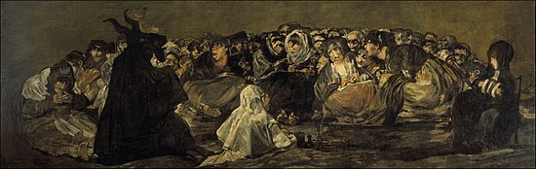

Module title
Early modern Europe – culture:
WITCHCRAFT IN EUROPE, c.1450-c.1650

Module content
This module explores the phenomenon of witchcraft in Europe during the era of the Renaissance, the Reformations and the Scientific Revolution when thousands of people (the majority of them women) were executed for witchcraft. We explores how major social, political, and cultural changes of the period (notably state formation, Christian Humanism, Protestant and Catholic Reformations, New science, and skepticism) shaped belief in and practice of witchcraft at all levels of society. We examine contemporaries’ beliefs about different types of magic, supernatural forces and reported experiences of bewitchment and witch sabbaths. Witchcraft was regarded, indeed feared, as an exceptional crime, during this period. Many members of Europe’s learned elite published highly influential works on witchcraft and its eradication, including the German Dominican inquisitor, Heinrich Kramer and the French jurist and political philosopher, Jean Bodin: their ideas are explored in-class through examination of extracts from their most important texts. Europe’s experience of witch hunting is explored through case studies of hunts in selected localities across Europe, notably in Germany, France, Scotland, England and Ireland for which we analyse contemporary printed and visual sources. The module concludes by investigating the reasons for the decline in witchcraft and witch hunting during the late seventeenth century.

Assessment
Research project (4,500 words approx.) on topic agreed in advance with lecturer 80%
Primary source analysis (750 words approx.) submission mid-term 10%
Participation 10%
Deadline for submission of essay: Monday, 13 May 2024

Reading
Brian Levack, The witch-hunt in early modern Europe (4th edn., London, 2015) available in MU bookstore and MU library (133.4094 LEV)
Brian Levack, The witchcraft sourcebook (London, 2004 edn. EBook full text online via MU library)
Brian Levack, The Oxford handbook of witchcraft in early modern Europe and colonial America (Oxford, 2013), available in MU library (133.430903 LEV)
national university of ireland, maynooth
department of history
second arts, 2023-24
Second Semester
Lecturer  PROFESSOR IAN SPELLER | Module code HY 2001 | Credits  5 | Lecture hours per week  Two

Module title
INTRODUCTION TO MILITARY HISTORY AND WAR STUDIES

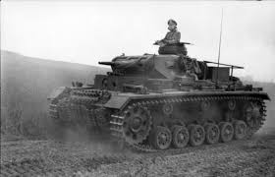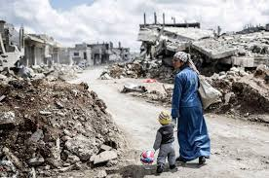

The module will provide an introduction to the study of war in the past and in the present. It will draw on methodologies of military history and strategic studies to explore alternative ideas as to the causes, conduct and impact of war. It will include an exploration of the economic, political, societal impact of war, including engagement with ideas about race, gender and war. In addition, a range of battles and campaigns will be examined in order to foster an understanding of evolution in the theory and practice of war over the course of the last century.

Form of Assessment:
- Essay: maximum 3,000 words (excluding footnotes/bibliography) chosen from list provided by the lecturer. Deadline 13 May 2024. (70%)
- Contribution to weekly Forum (online via Moodle) (10%)
- 10 minute Podcast. Completed during Semester. (20%)

Module Structure
The module consists of 2 x one hour classes each week, in addition to preparatory reading that students will complete in their own time. Students are expected to attend all classes and will be expected to prepare appropriately and thus be able to contribute to in-class discussion and debate.

Learning Outcomes
On completion of this modules students will be able to:

- Identify appropriate methodologies for military history
- Critique alternative explanations for the causes of war and conflict
- Demonstrate understanding of changes in the conduct of war over the past century.
- Explore the impact of war on society, and of society on war.
- Examine key debates on current security issues
- Present their ideas in a convincing manner, with reference to relevant history
national university of ireland, maynooth
department of history
second arts, 2023-24
Second Semester
Lecturer  DR JACK CRANGLE | Module code HY2003 | Credits  5 | Lecture hours per week  Two

Module title
RACE, IMMIGRATION AND MULTICULTURALISM IN BRITAIN AND IRELAND, 1900-PRESENT
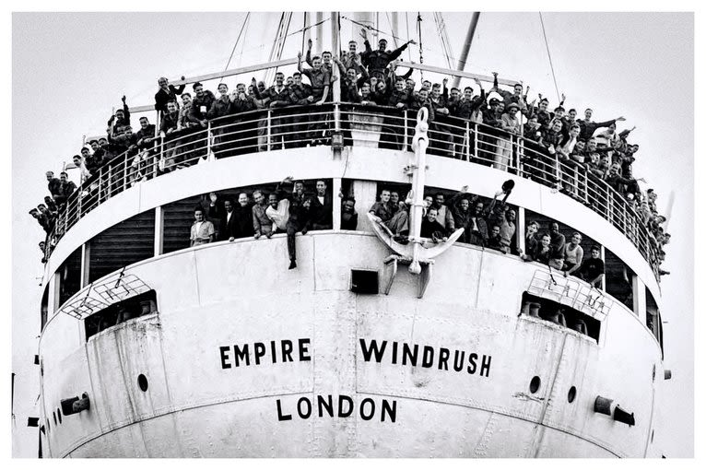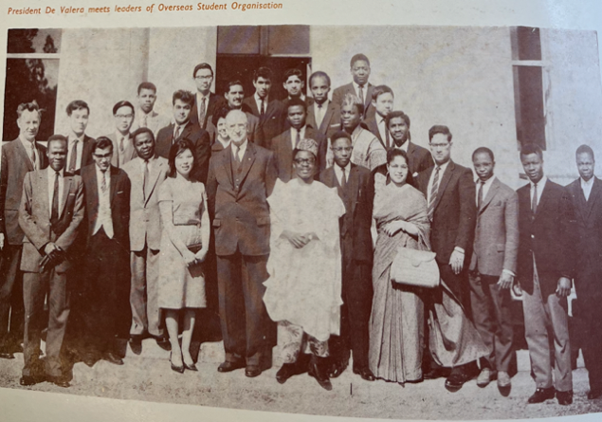
Module content
In 2023, both Britain and Ireland are diverse, multicultural nations. However, both places took very different paths before ending up here. Britain witnessed widespread immigration during the twentieth century, with over a million people arriving from its former Empire, including countries in the Caribbean, South Asia and Ireland itself. Contrastingly, Ireland was largely a country of emigration, with a stagnant economy compelling millions of young people to depart. Yet, both stories are more complex. Britain was anything but a multicultural paradise, witnessing race riots, political xenophobia and widespread discrimination. Although immigration to Ireland was low, thousands of Black and Asian people moved there during the twentieth century, while hundreds of mixed-race Irish born children suffered abuse in state institutions. One thing both places had in common was a default to the norm of whiteness, with ‘Britishness’ and ‘Irishness’ often assumed to be exclusively white identities. While racism in Britain was more overt, Ireland harboured its own anti-Black prejudices. This module compares and contrasts the immigration stories of Britain and Ireland, asking students to critically assess attitudes towards race, diversity and multiculturalism. It also traces how people of colour experienced living in those respective countries, asking how ‘British’ and ‘Irish’ national identities fostered feelings of exclusion or inclusion and discrimination or belonging.
Module aim
Students will understand how British and Irish experiences of immigration differed throughout the twentieth century and how both became diverse, multi-cultural nations. Students will begin to appreciate how national identity intersected with race and ethnicity to foster both exclusion and belonging.

Assessment:
3,500 word essay, deadline Monday, 13 May 2024 75%
Presentations 15%
Participation grade 10%
national university of ireland, maynooth
department of history
second arts, 2023-24

Second Semester
Lecturer  DR CIARAN REILLY | Module code HY2006 | Credits  5 | Lecture hours per week  Two

Module title
THE GAELIC ATHLETIC ASSOCIATION AND NATIONALISM

Module content
This module is designed to provide students with a broad introduction to the development of the Gaelic Athletic Association (GAA) towards the end of the nineteenth century and the part the organisation played in the development of nationalism and the cultural revival.

Learning outcomes
On successful completion of the module, students should be able to:
- Understand the context in which the GAA was founded and developed.
- identify primary sources relevant to the study of the GAA and nationalism.
- analyse and critically assess both primary and secondary historical sources relating to the topic.
Assessment
In-class participation 10%
In-class presentation 20%
Essay (3,500 words) on topic agreed in advance with lecturer 70%
Deadline for submission of essay: Monday, 13 May 2024

Special requirements (e.g. field trips)
A visit to the GAA Museum, Croke Park The trip will cost students around €15 each. All participants in the module are expected to attend all classes and the field trip. Further details will be provided in class and on Moodle.

national university of ireland, maynooth
department of history
second arts, 2023-24
Second Semester
Lecturer  PROFESSOR ROISÍN HIGGINS | Module code HY2007 | Credits  5 | Lecture hours per week  Two

Module title
A HISTORY OF SPORT IN MODERN IRELAND

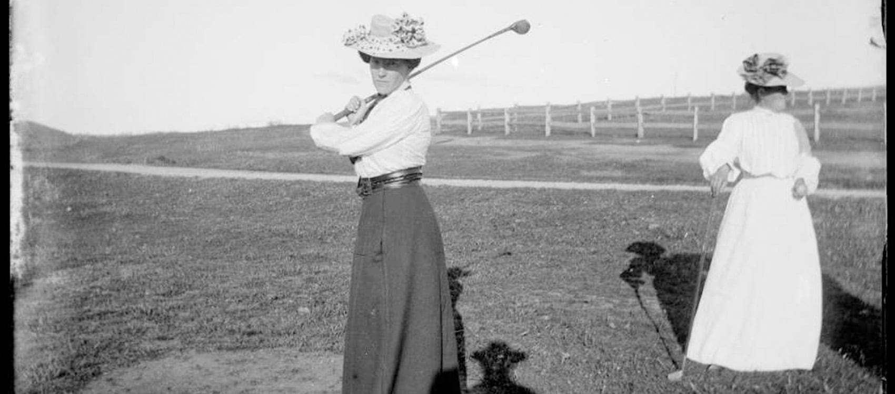

Module content
This module explores the modernisation of sport in Ireland during the nineteenth and twentieth centuries. It examines the social, economic and political forces that led to the codification of sport and how these altered practices of leisure across the island. The module will focus on sports such as boxing, cycling, soccer, golf, horse racing, motor racing and Gaelic Games, and examine them through a prism of imperialism, state formation, partition, gambling, transport infrastructure and identity. Students will consider the ways in which gender, social class and education determined how leisure time was spent and explore the ways in which modernisation and commercialism changed Ireland’s built sporting landscape.
Module Aims
Students will identify and analyse the economic, social and political contexts of changes to sport in Ireland. They will gain an understanding of the significance of the gender, class and education in determining who participates in sporting activities and critically engage with primary material and historiographical debate.

Assessment
Participation 10%
In-class presentation 20%
3,500-word essay (deadline for submission 13 May 2023) 70%
national university of ireland, maynooth
department of history
second arts, 2023-24

Second Semester
Lecturer | Module code SG254 | Credits  5 | Lecture hours per week

Module title
HISTORY 2 - LAW, SOCIETY AND LEARNED CLASSES IN EARLY IRELAND

Information as per Course Finder, July 2023

Overview
This module focuses on the large surviving body of early Irish law, often popularly known as ‘Brehon law’, which was unique in medieval Europe for the volume and sophistication of the texts produced. The range and types of legal texts which survive from medieval Ireland will be explored, and a series of early Irish law tracts will be read (in English translations). These laws cover the regulation of violence; marriage, divorce, paternity, and sexual offences; social status and hierarchies; church-state relations; and much more besides. We will analyse how the law functioned and operated, and examine the status of the legal specialists who administered justice. The relationship between legal theory and historical reality will be considered and we will explore how legal texts can be used as a source of evidence for the workings of medieval Irish society.

Form of assessment

Examination (60 minutes) 50%

Continuous assessment (one essay) 50%

Please note that SG254 is timetabled by Early Irish (Sean-Ghaeilge) and may clash with core lectures in other subjects.

national university of ireland, maynooth
department of history
second arts, 2023-24

Second Semester
Co-ordinator | Module code GC224 | Credits  5

Module title
UNDERSTANDING THUCYDIDES: THE FLOWERING OF GREEK HISTORIOGRAPHY

Information as per Course Finder, July 2023
Overview
Towards the end of the fifth-century BC the Greek world became embroiled in a conflict which lasted with little interruption for 27 years. This module examines this conflict – the Peloponnesian War – and the parts played by the principal adversaries, Athens and Sparta. Central to it is a close study of the Greek historian Thucydides’ account of this war. In particular, we examine the principles of historiography that he employed. On account of his methodology, Thucydides would acquire a reputation as the first scientific historian of the western world, a claim the module scrutinizes. We also, briefly, makes use of other perspectives, such as those provided by the comic playwright Aristophanes, who enriches the picture, adding a cultural dimension by examining the impact that the war had on the general population, male and female, citizen and slave. The module closes with an assessment of the legacy of Thucydides and his place in the Greek historiographical tradition.

Form of assessment

Continuous assessment (essay): 40%
Examination (90 minutes) 60%

Teaching & learning methods
18 lectures, 3 labs/practicals

For further information please contact Ancient Classics Department

Please note that GC224 is timetabled by Ancient Classics and may clash with core lectures in other subjects.

