National University of Ireland, Maynooth

DEPARTMENT OF HISTORY

FLYERS FOR OPTIONAL MODULES

II ARTS SEMESTER 1 2023-24

PLEASE NOTE

Flyers provide information supplementary to that available in module descriptors, which may be viewed on the university database at www.maynoothuniversity.ie/courses.

Students are expected to consult both flyers and module descriptors, as well as the academic timetable, in advance of registration.

national university of ireland, maynooth
department of history
second arts, 2023-24
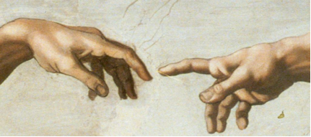
First Semester
Lecturer  DR ALISON FITZGERALD | Module code HY233 | Credits  5 | Lecture hours per week  Two
Module title:

PICTURING THE RENAISSANCE

Module Content:
This elective examines European visual culture during the Renaissance period, with a particular focus on Italy. It explores the production and consumption of art and the role of politics and patronage in shaping the art market. Primary sources, including artists’ biographies, letters, diaries and treatises on art, will be used to consider the ‘rebirth’ of interest in the ancient world, and the artistic developments which lead to the High Renaissance. While focusing primarily on painting, it also considers other media, including sculpture, print and decorative arts. Issues such as the use of art in public and private spaces, artist-patron relationships and the materials and techniques deployed by leading artists such as Michelangelo and Raphael will be investigated.

Learning outcomes:
- An understanding of key artistic developments in Italy during the Renaissance.
- Familiarity with primary sources which facilitate understanding of the context in which art was made, sold, valued and displayed in Renaissance Italy.
- Understanding of patterns of patronage and the commissioning of art for public and private spaces.
- Awareness of the wider context of the art market in Northern Europe and the ways in which ideas about art were communicated.
- Familiarity with the principal materials and artistic processes used to make art in this period.
No previous knowledge of the History of Art is required to take this elective.

Assessment:
Participation: 10%
In-class test: 20%
Essay (3,000-3,500 words) 70% Essay deadline: Monday, 8 January 2024
national university of ireland, maynooth
department of history
second arts, 2023-24
First Semester
Lecturer  DR JONATHAN WRIGHT | Module code HY 272 | Credits  5 | Lecture hours per week  Two

Module title
MODERN BRITISH ELECTIVE
SLAVERY AND ANTI-SLAVERY IN THE BRITISH WORLD, c. 1750-1833
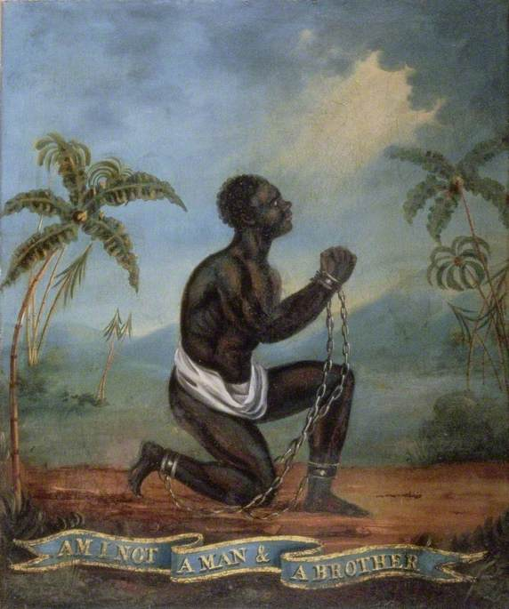
Module content
In 1562, John Hawkins captured 300 Africans from Sierra Leone, inaugurating British involvement in ‘the largest forced migration in history’ – the Atlantic slave-trade. By the mid-eighteenth century, Britain had become a leading player in the trade of enslaved people, and slavery had become central to the Atlantic economy. Forcibly transported to the British colonies in America and the West Indies, enslaved African produced sugar, tobacco and, above all, profits. Vast fortunes were made on the back of the slave trade and transatlantic slavery impacted British society in multiple ways. Yet, by 1807 the trade in enslaved people had been prohibited by parliament, and while slavery persisted as an institution in Britain’s colonies, this too was abolished in 1833.

This module will explore the character of British involvement in the slave trade, and will examine the reasons for its abolition and its long–term consequences. Situating Britain within the wider ‘Atlantic world’, the module will stress that slavery was not just something that happened ‘over there’, in the colonies, but something that had real and tangible consequences ‘at home’ in Britain, and will address a range of themes, including: the middle passage and the triangular trade; plantation life and slave rebellion; consumption and the cultural impact of slavery; abolition; and the continuing legacies of slavery.

Module aim
Having completed this module you will have engaged with key historiographical debates relating both to slavery and the ‘Atlantic World’, and will have developed a nuanced understanding of the multifaceted nature of British involvement in the slave trade and an appreciation of its on-going significance. In addition, you will have used a range of traditional and online archival resources, and will have been given an opportunity to develop your written presentation skills by completing assignments.

Assessment:
1,250 word assignment 25%
1,250 word assignment 25%
2,500 word essay 50% (deadline Monday, 8 January 2024
national university of ireland, maynooth
department of history
Second arts, 2023-24
First Semester
Lecturer  DR RAUL CARSTOCEA | Module code HY 281 | Credits  5 | Lecture hours per week  Two

Module title
Modern Europe elective
THE GEOGRAPHY OF GENOCIDE: THE HOLOCAUST IN EASTERN EUROPE
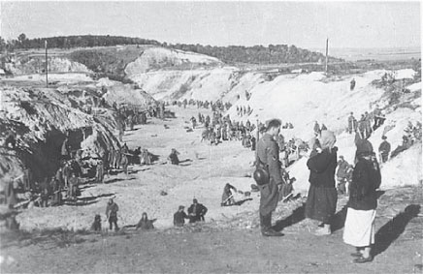
German soldiers supervising Soviet POWs covering a mass grave. Babi Yar, Ukraine, October 1941
Module content
Recent studies of the Holocaust have emphasized the role of local perpetrators and Nazi-allied regimes, drawing attention to previously ‘forgotten’ cases or victim groups. This has led to an increased focus on Eastern Europe, as the area where most of the killing occurred and where most of the victims (well over five million, approximately 90%, of the Jews killed in the Holocaust) originated from, as well as on actors other than the Nazis who bear responsibility for carrying out the genocide. Using a variety of primary sources, including memoirs and diaries, contemporary newspapers, official statements and minutes of government sessions, documents from post-1945 war crimes trials, and survivors’ testimonies, we will explore the course of the Holocaust in Eastern Europe, drawing attention to the differentiated geography of the genocide.
Module aim
The core aim of this module is to provide a broader perspective on the Holocaust that goes beyond a focus on Nazi perpetrators and Jewish victims. Students will engage with key historiographic debates regarding the Holocaust and will develop a nuanced understanding of its complexity, as well as of its ongoing significance for memory politics in Eastern Europe.
Assessment
Class participation 10%
Primary source analysis (1500 words) 30%
Essay (3000 words) 60%
Deadline for submission of essay: Monday, 8 January 2024
national university of ireland, Maynooth
department of history
second arts, 2023-24
First Semester
Module Co-ordinator  DR MICHAEL POTTERTON | Module code  HY 292 | Credits  5 | Lecture hours per week  Two (+ field trips)

Module title:
IRELAND IN PREHISTORY

Module Content
Ireland has been inhabited by humans for over twelve thousand years, with each generation leaving its own marks – some more easily deciphered than others. In the absence of contemporary written documents, students of prehistory must rely mainly on archaeological sources to learn about the people of those times. Careful analysis of ancient landscapes, monuments and artefacts can shed important light on the activities, lifestyles, economies, diets, beliefs and priorities of the people of prehistoric Ireland. Excavation and other archaeological methods continue to reveal fascinating insights into the lives and deaths of our ancestors and their ways of life. This module introduces students to the remarkable story of humans in Ireland from stone-age beginnings to the advent of Christianity and writing in the fifth century. By means of illustrated lectures and field trips, we will explore Ireland’s rich and varied prehistoric landscape. The module also examines how modern archaeologists use twenty-first-century techniques and technology to explore ancient landscapes.

Module aim
The core aim of this module is to familiarise students with aspects of prehistoric human activity in Ireland from the earliest times to the fifth century. Illustrated lectures will guide participants on a virtual tour of the sites, monuments and landscapes of prehistoric Ireland. Using specific examples, we will examine when, why and how they were constructed, who was responsible, what it was like to live, work and die during those periods and what significance this has in the twenty-first century. Field trips to prehistoric sites and to the National Museum of Ireland will provide another dimension to this module. Upon successful completion of the module, students will
- understand the basic chronology of prehistoric Ireland;
- be able to identify a range of prehistoric monument types;
- be familiar with a variety of artefacts used by prehistoric people in Ireland;
- be aware of modern archaeological techniques and technology.

Form of assessment: There are three parts to the assessment for this module:
a. one in-class test 25% of module marks
b. one illustrated project (3,000 words) due Monday, 8 January 2024 65% of module marks
c. participation in class 10% of module marks

Special requirements
There will be two Saturday field trips: one half-day visit to the National Museum of Ireland on Kildare Street, Dublin (students are expected to make their own way to and from the museum). The other trip will depart via coach from Maynooth and visit several prehistoric sites in the Boyne Valley. All participants in the module are expected to attend both field trips and there is a fee of €20 per student as a contribution towards costs. Further details will be provided in class/on Moodle.
national university of ireland, maynooth
department of history
second arts, 2023-24

First Semester
Lecturer  DR DYMPNA MC LOUGHLIN | Module code HY 299 | Credits  5 | Lecture hours per week  Two

Module title
Modern Ireland Social Elective (B)
POVERTY AND WELFARE IN PRE-FAMINE IRELAND, 1800-1845

Overview
The aim of this module is to analyze Irish society, Institutions, family life, disease and death in the prefamine period. Attention will also be paid to the economy, the deteriorating condition of laborers and their families, the ubiquity of public begging by this group, and their political response to their situation in the form of secret societies.
This elective will also engage with the issues emerging from the provision of medical welfare to the destitute in the form of dispensaries, county infirmaries, and a system of county lunatic asylums. It will also discuss the debate over the provision of a system of social welfare to the poor in the form of the poor law Act 1838. Contemporary discussions about charity and poverty will also be included. The issue of public works will also be discussed as work was the key form of welfare favored by the destitute in the prefamine period.
The situation of children on the margins of prefamine society will also be a focus of this module. This will include an analysis of the situation of infants in the foundling hospitals as well as those placed at nurse in the countryside. Young children orphaned as a result of the 1832 cholera epidemic will also be included in the discussion of children and welfare in the pre famine period.
Key outcomes of this module
- Students will have a broad understanding of prefamine Ireland.
- Students will have specific knowledge of all the groups in distress, such as cottiers and labourers and their families.
- Students will understand some of the ways cottiers, labourers and their families reacted to poverty and distress through their involvement in secret societies.
- Students will be aware of the role of the British state in pre famine Ireland and their provision of medical and social welfare to the poor.
- Students will be able to identify the difficulties faced by foundlings and cholera orphans in prefamine Ireland and how these two groups ultimately fared.
Form of assessment
Analysis of primary sources document (1500 words) due mid semester 25%
Essay based on a mixture of primary and secondary sources (3500 words)
due Monday, 8 January 2024 65%
Participation 10%
A range of secondary source documents will be provided and discussed in class. Students then can make their own selection.

national university of ireland, maynooth
department of history
second arts, 2023-24

First Semester
Lecturer  PROFESSOR ROISÍN HIGGINS | Module code HY 2004 | Credits  5 | Lecture hours per week  Two

Module title
A HISTORY OF ULSTER, 1886-1972

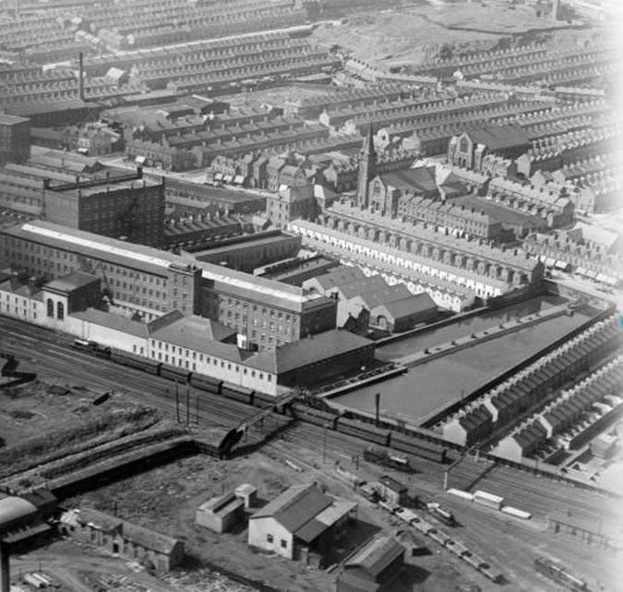
Overview
This module will examine the economic, political and social history of Ulster from the first Home Rule Bill in 1886 to the reinstatement in Northern Ireland of Direct Rule from Westminster in 1972. It will cover areas including revolution, war, partition and the history of the Northern Irish state. Topics will include religion, employment/unemployment, housing, education, families and welfare. There has been a growing interest in the history and politics of partition, and this course will provide a greater understanding of the historical context for the establishment of the Irish border, its impact on the province of Ulster, and on the lives of those who lived along and within bordered land.

Key Objectives
By the end of this module, students will have a critical understanding of the economic, social, and political history of Ulster from 1886 to 1972. They will be able to assess the causes and consequences of partition and reflect upon the causes of division and civil unrest during this period.

Form of assessment
Class participation 10%
Class presentation (December) 20%
Essay of 3,500 words (deadline 8 January 2024) 70%
national university of ireland, maynooth
department of history
second arts, 2023-24

First Semester
Lecturer  PROF DEJAN DJOKIĆ | Module code HY 2009 | Credits  5 | Lecture hours per week  Two

Module title
SEARCHING FOR PEACE DURING THE COLD WAR

Overview

Yugoslavia is usually associated with political violence and ethno-religious wars. This module suggests an alternative approach: during its existence (1918-1991), but particularly after 1945, the Yugoslav state offered globally influential models for multi-ethnic co-existence and world peace. The module seeks to explain, in historical and comparative contexts, how this Balkan country, under the leadership of Tito and the Communist Party, re-emerged from the Second World War as a multi-ethnic federation which developed its own brand of socialism; and how it became one of the founders of the Non-Aligned Movement, which offered an alternative to the US-led western and Soviet-led eastern blocs in an aim to prevent a global war.

Form of assessment
5,000 word essay or shorter essay combined with class assignments/tests. Breakdown to be confirmed.
Deadline for submission of essay Monday, 8 January 2024

national university of ireland, maynooth
department of history
second arts, 2023-24

First Semester
Lecturer | Module code SG253 | Credits  5 | Lecture hours per week

Module title
EARLY IRELAND, FROM ST PATRICK TO THE BATTLE OF CLONTARF

Information as per Course Finder, July 2023

Overview
This module offers an introduction to early Irish history, beginning with the life of St Patrick in the fifth century and ending with the death of King Brian Boru at the Battle of Clontarf in 1014. Key themes from the history of early medieval Ireland will be explored, including kingship, identity, social relations, and religion. This module provides a foundational overview of Ireland’s early history and will introduce you to some of the most important primary sources from that period. An era of violence, political struggles and social inequality, it was also a time of great cultural sophistication, when Ireland had a reputation as the ‘island of saints and scholars’. Both aspects of this fascinating period of history will be explored.

24 lecture hours

Form of assessment

50% examination (60 minutes)

50% continuous assessment (one essay)

Please note that SG253 is timetabled by Early Irish (Sean-Ghaeilge) and may clash
with core lectures in other subjects.

For further details contact Early Irish (Sean-Ghaeilge)

national university of ireland, maynooth
department of history
second arts, 2023-24

First Semester
Lecturer | Module code GC217 | Credits  5 | Lecture hours per week

Module title
POWER AND THE PEOPLE IN IMPERIAL ROME

Information as per Course Finder, July 2023

Overview
The Roman empire reached its greatest extent in the first and second centuries AD, when at the height of its power it governed territories from Syria to Spain, and from Scotland to the Sahara desert. This module focuses on the nature of Roman government and society in the imperial period, looking closely both at those who exercised Roman power and authority and those who experienced it or who set out to oppose it. The module, however, seeks to move beyond simplistic models of rulers and ruled, or of
‘imperialism’ and ‘Romanisation’; instead it makes use of a diverse range of sources from across the empire as a way of identifying the exercise of social, economic and political power at multiple levels of Roman society and in even the farthest reaches of the Roman world.
18 lecture hours, 3 workshops/tutorials
Assessment
100% Continuous Assessment detail(s): 2 compulsory written assignments.

Please note that GC217 is timetabled by Ancient Classics and may clash
with core lectures in other subjects.

For further details contact Ancient Classics Department

