National University of Ireland, Maynooth

DEPARTMENT OF HISTORY

FLYERS FOR OPTIONAL MODULES

II ARTS SEMESTER 1 2020-21

PLEASE NOTE

Flyers provide information supplementary to that available in module descriptors, which may be viewed on the university database at www.maynoothuniversity.ie/courses.

Students are expected to consult both flyers and module descriptors in advance of registration.

national university of ireland, maynooth
department of history
second arts, 2020-21
First Semester
Lecturer  DR HUSSAM AHMED | Module code HY 201 | Credits  5 | Lecture hours per week  Two

Module title
DOCUMENTS IN HISTORY, LEVEL 2

Overview

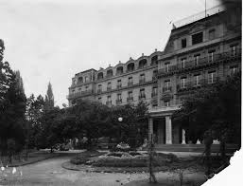
In this module, students will be introduced to classifying and analysing historical documents as material objects. Structured around a major theme or period in history, in this case the Wilsonian moment after WWI, the League of Nations and the Mandate system, students will critically engage with various types and structures of documentary and ancillary evidence used to present cogent interpretations of the past.

Students will be familiarised with the primary sources which are available for the study of the advocacy of self-determination and its impact on the colonised peoples after the end of WWI, how to locate these sources, and how to critically assess their strengths and weaknesses to present coherent historical arguments.

Lectures will be delivered in accordance with the University’s guidelines for a safe campus. Should the need arise, this module might have to move to online delivery. Due notice will be given if this is the case.

Assessment

Participation 10%
Presentation 10%
Primary source analysis (1,000 words) 20%
Research project (2,500-3,000 words) 60%

Deadline for submission of essay: Monday, 4 January 2021

national university of ireland, maynooth
department of history
second arts, 2020-21
First Semester
Lecturer  DR HUSSAM AHMED | Module code HY 215 | Credits  5 | Lecture hours per week  Two

Module title
HISTORY OF THE ARAB-ISRAELI CONFLICT

Overview
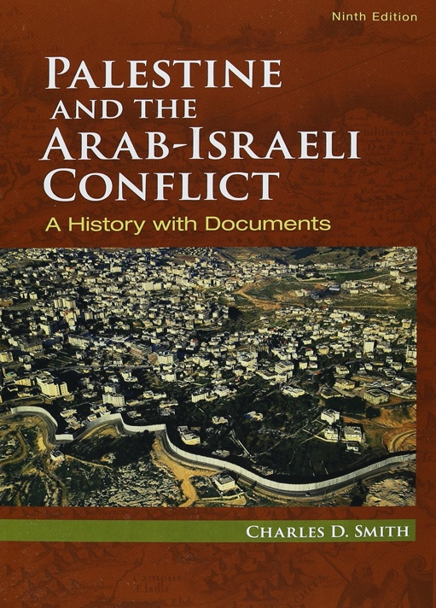
The aim of this module is to provide students with an overview of the political, military and diplomatic history of the Arab-Israeli Conflict. The module will proceed chronologically, and cover the following topics: the emergence of Zionism in late-19th-Century Europe, early Jewish settlement in Palestine, Palestinian society at the beginning of the 20th Century, WW1 and British rule, the 1936-1939 Arab Revolt and Jewish responses, the 1948 Arab-Israeli War, Israeli-Arab relations in the 1950s, the Suez War, the 1967 War, Israel and the West Bank and Gaza, the 1973 War and Camp David I, Israel in Lebanon, the First Intifada, the Madrid and Oslo peace processes, Camp David II, and finally the Second Intifada, the Wall, and the conflicts with Hezbollah and Hamas.

We shall also focus on a number of historiographical debates over specific issues such as the causes and consequences of the 1948 and 1967 Wars, and the failures of the various peace initiatives. In this way students will be exposed to the competing historical narratives that dominate the writing of this conflict’s past. For this module, the main textbook will be Charles D. Smith’s Palestine and the Arab-Israeli Conflict: A History with Documents.

Lectures will be delivered in accordance with the University’s guidelines for a safe campus. Should the need arise, this module might have to move to online delivery. Due notice will be given if this is the case.

Assessment

Participation 10%
Primary source analysis (1,500 words) 30%
Final essay (3,000-3,500 words) 60%

Deadline for submission of essay: Monday, 4 January 2021

national university of ireland, maynooth
department of history
second arts, 2020-21

First Semester
Lecturer  DR DAVID MURPHY | Module code HY 216 | Credits  5 | Lecture hours per week  Two

Module title
A HISTORY OF WARFARE: FROM PLATO TO NATO

Module content:

The module will provide an overview of the history of warfare from classical times to the present. Starting with Greek and Roman warfare, it will address key developments in strategy, tactics and technology through the centuries. It will cover a wide range of issues and students will analyse the conduct of war on land, sea and (where relevant) in the air. There will be discussion of key strategic theorists and commanders. Current issues such as counterinsurgency and nuclear arms will be discussed.

On successful completion of the module, students should be able to understand the major developments that changed the character of warfare during this period. They should be able to address key historiographical debates and analyse specific battles and campaigns.

Form of assessment
Assignment 1 – Book review of 1,500 words submitted at the end of Semester 1 30%
Assignment 2 – Essay of 3,500 words. 70%
Deadline for submission of essay: Monday, 4 January 2021

Module Structure:
This module will be lecture-based

PLEASE NOTE: Lectures will be delivered in accordance with the University’s guidelines for a safe campus. Should the need arise, this module might have to move to online delivery. Due notice will be given if this is the case.

national university of ireland, maynooth
department of history
second arts, 2010-21

First Semester
Module Co-ordinator  DR MICHAEL POTTERTON | Module code  HY 224 | Credits  5 | Lecture hours per week  Two

Module title:
SETTLEMENT AND SOCIETY IN IRELAND

Module content
Ireland boasts one of the most abundant archaeological and historical landscapes in the world. It is especially rich and varied for the Middle Ages – from the advent of Christianity in the fifth century to the dissolution of the monasteries over a millennium later in the 1530s and 1540s. The fifth century also marks the beginning of writing in Ireland and the start of our documented history. Combining the evidence of written sources with what we know from archaeology and the visible physical remains of the past we can recreate a vivid picture of life in medieval Ireland. We can start to understand, for example, where and how people lived, what their daily lives were like, what they ate and drank, how society was structured, how they practised religion, how they dealt with death, and much more.

Module aim
The core aim of this module is to familiarise students with aspects of settlement and society across the island of Ireland from the beginning of recorded history in the early medieval period to the end of the Middle Ages. Illustrated lectures will guide participants on a virtual tour of the sites, monuments and landscapes of medieval Ireland. Using specific examples, we will examine when, why and how they were constructed, who was responsible, what it was like to live, work and die during that time and what significance this has in the twenty-first century. Upon successful completion of the module, students will
- be familiar with major developments in Ireland in the period c.AD400–1600;
- be aware of where and how people lived during this time;
- be able to recognise Irish medieval archaeological monuments and landscapes;
- understand the significance of the medieval past in the modern world.

NB: Lectures will be delivered in accordance with the University’s guidelines for a safe campus. Should the need arise, this module might have to move to online delivery. Due notice will be given if this is the case.

Form of assessment
There are two parts to the assessment for this module:
- one mid-term assignment (1,000 words; due November; 25% of module marks).
- one illustrated project (3,000 words; due by Monday, 4 January 2021; 75% of module marks).

national university of ireland, maynooth
department of history
second arts, 2020-21

First Semester
Lecturer  DR DYMPNA MC LOUGHLIN | Module code HY 232 | Credits  5 | Lecture hours per week  Two

Module title
Modern Ireland Social Elective (B)
THE SOCIAL HISTORY OF IRELAND IN THE NINETEENTH AND TWENTIETH CENTURIES

Module content
This wide-ranging elective on social history will focus on the working class. Gender will also be key component of all the lectures. Children and the elderly are probably the most forgotten groups in history, and the aim is to include them in as many of the lectures as possible. These two groups will figure prominently in the assessment of this module. A key part of the assessment of this elective will be working with primary sources, especially online British Parliamentary papers.

Key areas of study in this elective are
- Poverty and survival prior to the Famine
- Foundlings and Orphans
- Poverty and the Poor Law Inquiry
- The Poor Law Act of 1838, and the concept of welfare.
- The Famine - Obliteration of the Poor
- Post Famine Ireland and emergence of powerful political, religious and social elites.
- Twentieth century and the failed promises of Independence.
- Re- institutionalisation of the poor and the Industrial school system.
- Free education, The first real revolution in Ireland?
- Gender, marriage and the law

LECTURES WILL BE DELIVERED IN ACCORDANCE WITH THE UNIVERSITY’S GUIDELINES FOR A SAFE CAMPUS. SHOULD THE NEED ARISE, THIS MODULE MIGHT HAVE TO MOVE TO ONLINE DELIVERY. DUE NOTICE WILL BE GIVEN IN THIS CASE

Form of assessment
Each student will be assigned a small section of the Poor Law Inquiry for the purpose of compiling an essay on the subject. Students will have the opportunity to compile a draft or template of this essay for review and feedback by the course lecturer.
Essay Template, 1,000 words. DUE ON WEEK 6 25%
Essay on the Poor Law Inquiry (4,000 words) 75%
Deadline for submission of essay: Monday, 4 January 2021
national university of ireland, maynooth
department of history
second arts, 2020-21
First Semester
Lecturer  DR ALISON FITZGERALD | Module code HY233 | Credits  5 | Lecture hours per week  Two
Module title:

PICTURING THE RENAISSANCE
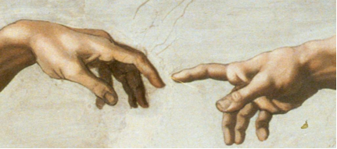

Module Content:
This elective examines European visual culture during the Renaissance period, with a particular focus on Italy. It explores the production and consumption of art and the role of politics and patronage in shaping the art market. Primary sources, including artists’ biographies, letters, diaries and treatises on art, will be used to consider the ‘rebirth’ of interest in the ancient world, and the artistic developments which lead to the High Renaissance. While focusing primarily on painting, it also considers other media, including sculpture, print and decorative arts. Issues such as the use of art in public and private spaces, artist-patron relationships and the materials and techniques deployed by leading artists such as Michelangelo and Raphael will be investigated.

No previous knowledge of the History of Art is required to take this elective.

Lectures will be delivered in accordance with the University’s guidelines for a safe campus. Should the need arise, this module might have to move to online delivery. Due notice will be given if this is the case.

Assessment:
In-class assessment: 30%
Essay (3,000-3,500 words) 70%
Deadline: Monday, 4 January 2021

national university of ireland, maynooth
department of history
second arts, 2020-21
First Semester
Lecturer  PROF. TERENCE DOOLEY | Module code HY 270 | Credits  5 | Lecture hours per week  Two

Module title
REVOLUTION IN IRELAND, 1879-1923

Module content
This module looks at the long revolutionary period in Ireland stretching from the beginning of the Land War in 1879 to the passing of the Land Act in 1923. It assesses the social, cultural and political revolutions which took place over this period of time and how they impacted upon the lives of the various social classes, on Catholics and Protestants, Nationalists and Unionists, at both national and local levels. It examines such issues as the political and social impact of the extended land war from 1879 to 1923; the rise in militancy between 1912 and 1914; the impact of the Great War of 1914-18 on Irish life and politics; the causes and consequences of the Easter Rising 1916; how the War of Independence played itself out at local level; and finally the origins and repercussions of the civil war in 1922-23.

An important aspect of the module will be to introduce students to the primary sources available for the study of the period, how to locate these, and how to assess their strengths and weaknesses.

Aim
To teach an understanding of the causes and effects of social, cultural and political revolution at national and local levels in Ireland from the beginning of the Land War in 1879 to the end of the Civil War in 1923.
Form of assessment
Mid-term assignment (1500 words) based on selected document(s) 30%
Submission deadline: end of week 6
Essay of 3,500 words 70%
Deadline for submission of essay: Monday, 4 January 2021

Lectures will be delivered in accordance with the University’s guidelines for a safe campus. Should the need arise, this module might have to move to online delivery. Due notice will be given if this is the case.

Prescribed core text: Alvin Jackson, Ireland 1798-1998: war, peace and beyond (Oxford, 1999, 2nd ed. 2010), pp 69-257
national university of ireland, maynooth
department of history
second arts, 2020-21
First Semester
Lecturer  DR JONATHAN WRIGHT | Module code HY 272 | Credits  5 | Lecture hours per week  Two

Module title
MODERN BRITISH ELECTIVE
SLAVERY AND ANTI-SLAVERY IN THE BRITISH WORLD, c. 1750-1833
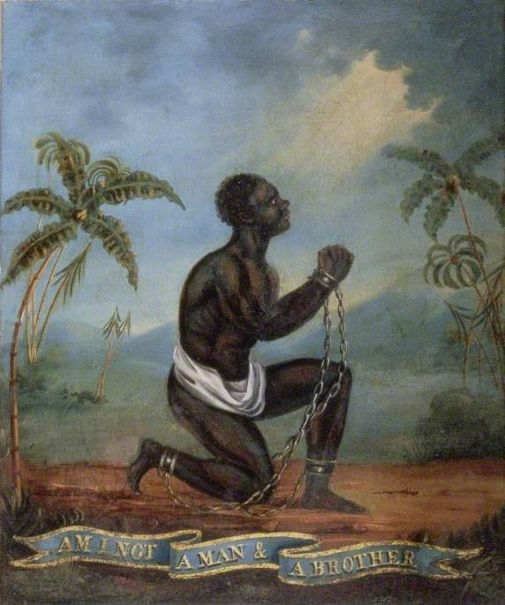
Module content
In 1562, John Hawkins captured 300 Africans from Sierra Leone, inaugurating British involvement in ‘the largest forced migration in history’ – the Atlantic slave-trade. By the mid-eighteenth century, Britain had become a leading player in the trade of enslaved people, and slavery had become central to the Atlantic economy. Forcibly transported to the British colonies in America and the West Indies, enslaved African produced sugar, tobacco and, above all, profits. Vast fortunes were made on the back of the slave trade and transatlantic slavery impacted British society in multiple ways. Yet, by 1807 the trade in enslaved people had been prohibited by parliament, and while slavery persisted as an institution in Britain’s colonies, this too was abolished in 1833.

This module will explore the character of British involvement in the slave trade, and will examine the reasons for its abolition and its long–term consequences. Situating Britain within the wider ‘Atlantic world’, the module will stress that slavery was not just something that happened ‘over there’, in the colonies, but something that had real and tangible consequences ‘at home’ in Britain, and will address a range of themes, including: the middle passage and the triangular trade; plantation life and slave rebellion; consumption and the cultural impact of slavery; abolition; and the continuing legacies of slavery.

Module aim
Having completed this module you will have engaged with key historiographical debates relating both to slavery and the ‘Atlantic World’, and will have developed a nuanced understanding of the multifaceted nature of British involvement in the slave trade and an appreciation of its on-going significance. In addition, you will have used a range of traditional and online archival resources, and will have been given an opportunity to develop your written presentation skills by completing assignments.

Please Note: Lectures will be delivered in accordance with the University’s guidelines for a safe campus. Should the need arise, this module might have to move to online delivery. Due notice will be given if this is the case.
Assessment: Analysis of primary source (c. 1,250 words) 20%
Primary source narrative (c. 1,250 words) 20%
Essay (c. 2,500 words: due Monday 4 Jan. 2021) 60%

national university of ireland, maynooth
department of history
second arts, 2020-21

First Semester
Lecturer  TBC | Module code SG253 | Credits  5 | Lecture hours per week

Module title
EARLY IRELAND, FROM ST PATRICK TO THE BATTLE OF CLONTARF

Overview
The first six hundred years of Irish history begin with St Patrick and the coming of Christianity and literacy and end with the battle of Clontarf in 1014, when Brian Boru is reputed to have driven the Vikings from Ireland. This module studies these earliest centuries of Ireland’s history.

24 lecture hours

Form of assessment

Continuous assessment 50%

One-hour examination at end of semester 50%

Please note that SG254 is timetabled by Early Irish (Sean-Ghaeilge) and may clash
with core lectures in other subjects.

For further details contact Early Irish (Sean-Ghaeilge)

national university of ireland, maynooth
department of history
second arts, 2020-21

First Semester
Lecturer  TBC | Module code GC217 | Credits  5 | Lecture hours per week

Module title
POWER AND THE PEOPLE IN IMPERIAL ROME

Information as per Course Finder, July 2020

Overview
The Roman empire reached its greatest extent in the first and second centuries AD, when at the height of its power it governed territories from Syria to Spain, and from Scotland to the Sahara desert. This module focuses on the nature of Roman government and society in the imperial period, looking closely both at those who exercised Roman power and authority and those who experienced it or who set out to oppose it. The module, however, seeks to move beyond simplistic models of rulers and ruled, or of
‘imperialism’ and ‘Romanisation’; instead it makes use of a diverse range of sources from across the empire as a way of identifying the exercise of social, economic and political power at multiple levels of Roman society and in even the farthest reaches of the Roman world.
18 lecture hours, 3 workshops/tutorials
Assessment
100% Continuous Assessment detail(s): 2 compulsory written assignments.

Please note that GC217 is timetabled by Ancient Classics and may clash
with core lectures in other subjects.

For further details contact Ancient Classics Department

