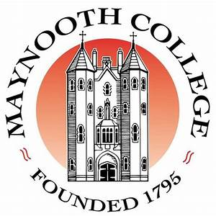

**Retired Staff Association,**

**Maynooth University and St. Patrick’s College Maynooth**

**Cumann na mBall Foirne ar Scor,**

**Ollscoil Mhá Nuad agus Coláiste Phádraig Má Nuad**

**FULL MEMBERSHIP APPLICATION FORM**

**FOIRM IARRATAIS ar BHALLRAÍOCHT IOMLÁN**

Name:……………………………………………………………………………………………………………………(print)

Address:…………………………………………………………………………………………………………………………………

……………………………………………………………………………………………………………………………(print)

Telephone No:………………………………………………………………..

Mobile No:………………………………………………………………………

Email:…………………………………………………………………

Name of the Department/School or Unit in which you worked:…………………………………………

As a Member would you wish

To be added to our email list? Yes ( ) No ( )

to receive text messages Yes ( ) No ( )

To receive communication through An Post Yes ( ) No ( )

Signature:……………………………………………………………………… Date:……………………………….