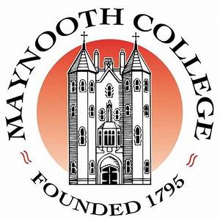


Retired Staff Association,
Maynooth University and St. Patrick’s College Maynooth
Cumann na mBall Foirne ar Scor,
Ollscoil Mhá Nuad agus Coláiste Phádraig Má Nuad

DISCLAIMER FORM
FOIRM SHÉANTA
I am an Associate Member of the above Association. I wish to confirm that I will not sue MU/SPCM Retired Staff Association or its Officers for damages/injuries incurred during any activity organised by the MU/SPCM Retired Staff Association

I will use my Private Health Insurance or PRSI Medical Card to cover the costs of any injuries sustained.
I will only use the Active Retirement Association insurance in the event of a shortfall from the other sources.

Signed:………………………………………………………………………………….
Associate Member

Witnessed:…………………………………………………………………………….

Associate Member Name:___________________________________(print)

Address:______________________________________________________

Mobile Number:_______________________

Email:-----------------------------------------

DATE:----------------------------------------------------

