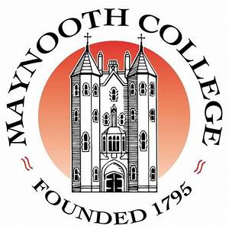


Retired Staff Association,
Maynooth University and St. Patrick’s College Maynooth
Cumann na mBall Foirne ar Scor,
Ollscoil Mhá Nuad agus Coláiste Phádraig Má Nuad

ASSOCIATE MEMBERSHIP APPLICATION FORM
FOIRM IARRATAIS ar BHALLRAÍOCHT CHOMHLACH

Please complete and tick the appropriate boxes

Name:…………………………………………………………………………………………………………………………………….

Address:…………………………………………………………………………………………………………………………………

…………………………………………………………………………………………………………………………………………….

Telephone No:………………………………………………………………..

Mobile No:………………………………………………………………………

Email Address:…………………………………………………………………

Should you become an Associate Member would you wish

to be added to our email list? Yes ( ) No ( )

to receive texts Yes ( ) No ( )

to receive communication through Post Yes ( ) No ( )

Signature:……………………………………………………………………… Date:……………………………….

To be completed by Sponsor

As a fully paid up member of the Retired Staff Association I am happy to:

Sponsor………………………………………………………………………………………… as an Associate Member.

I confirm that they are my : SPOUSE ( ) PARTNER ( ) ESTABLISHED FRIEND ( )

Signed:………………………………………………………………………… Date:…………………………………………..

