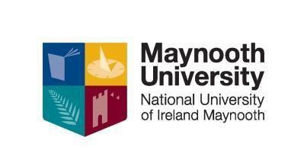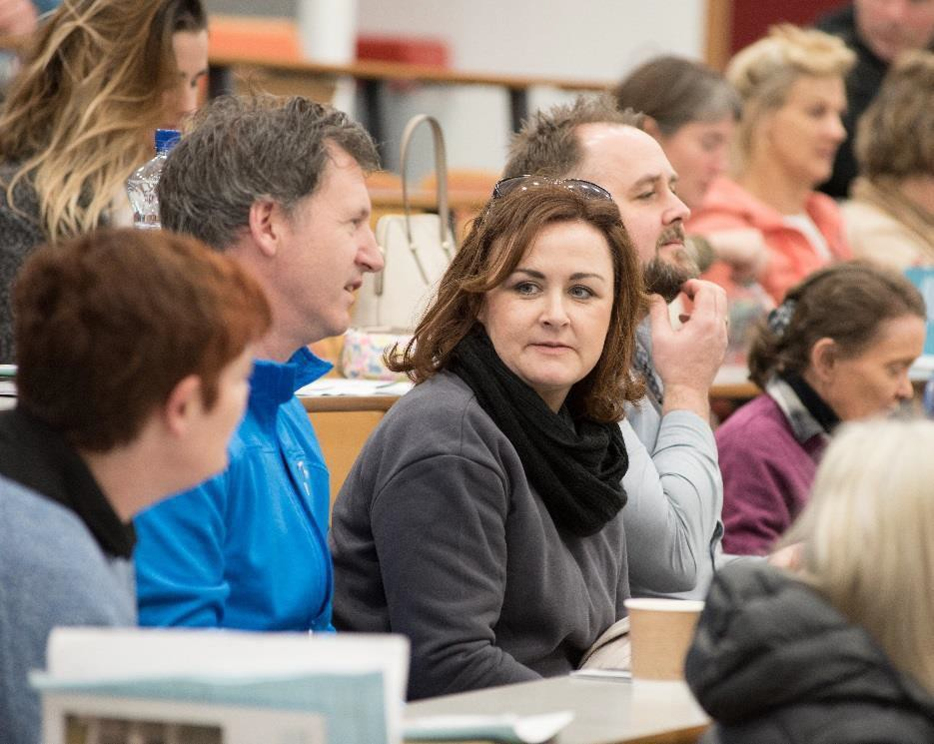

CERTIFICATE IN PSYCHOLOGY

Level 7 (20 ECTS)

This Certificate level course is designed to provide participants with the opportunity to develop an understanding of psychology and to explore its relevance to the individual, family, community and society. The course aims to introduce participants to the main psychological theories and examine their contribution to the development of the discipline.

WHO IS THIS QUALIFICATION FOR?
This course is aimed at people who would like a comprehensive introduction to the subject discipline of Psychology at university level.

OVERVIEW
Module 1 Introduction to Psychology and Study Skills; Overview of what psychology consists of, its history and study skills.

Module 2 The Biological Basis of Behaviour; Most behaviour is rooted in our biology; this module considers the role of the brain in sleep, sensation and perception.

Module 3 Learning and Feeling: This module focuses on how we learn, remember and experience emotions.

Module 4 Personality: This module reviews the most important theories of personality, and how personality is assessed under each of these theories.

Module 5 The Development of the Individual: This module considers the early development of the child from conception through to thought, language and moral development.

Module 6 Introduction to Social Psychology: Key areas in social psychology such as social perception, attitudes and prejudice will be explored in this module.

Module 7 Introduction to Abnormal Psychology: This module introduces students to the diagnosis, classification and treatment models in abnormal behaviour.

Module 8 Introduction to Social Research Methodology: An introduction to the main techniques involved in social research.

COURSE STRUCTURE:
The duration of the course is 100 hours. Students will attend 1 evening per week for a 3 hour facilitated workshop/tutorial. Students will also attend 3/4 Saturdays over the duration of the course.

DATES, VENUES AND FEES for 2023-2024
Cork College of Commerce: Tuesdays commencing October 2024 6.00-9.30pm
Scoil Mhuire Clane: Tuesdays commencing October 2024 7.00-10.00pm
Vita House Roscommon: Mondays October 7.00-.10 00pm (check with venue (090) 662 5898)
Pobalscoil Neasáin, School Lane, Baldoyle Tuesdays commencing October 2024 7.00-10.00pm

Students must be 21 on 1st January 2024.

An Easy Payment Plan is available upon registration. Part time students who are on courses at levels 6 to 10 on the framework of qualifications may be eligible to for the Student Assistance Fund (SAF) to help with the associated costs of attending a university course such as Travel, Childcare, Utilities, Materials etc. Once registered to this course you should first consult: SAF Guidelines to see if you qualify and then e-mail student.budget@mu.ie to make further enquiries.

CPD & PROGRESSION
The NUI Certificate in Psychology is a standalone qualification however when combined with the NUI Certificate in Training and Continuing Education (Train the Trainer Level 7) plus the Certificate Equality Studies (On Line) it forms part of the Diploma in Arts: Training and Development for Socially Inclusive Workplaces.

CONTACT US
Apply https://v2.pac.ie/institute/19 for Baldoyle, Clane and Cork from 1st May 2024 or to find out more about this and our other CPD courses please contact Kay Loughlin: 01 708 6062 or visit our website: https://www.maynoothuniversity.ie/adult-and-community- education/our-courses

