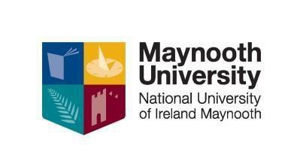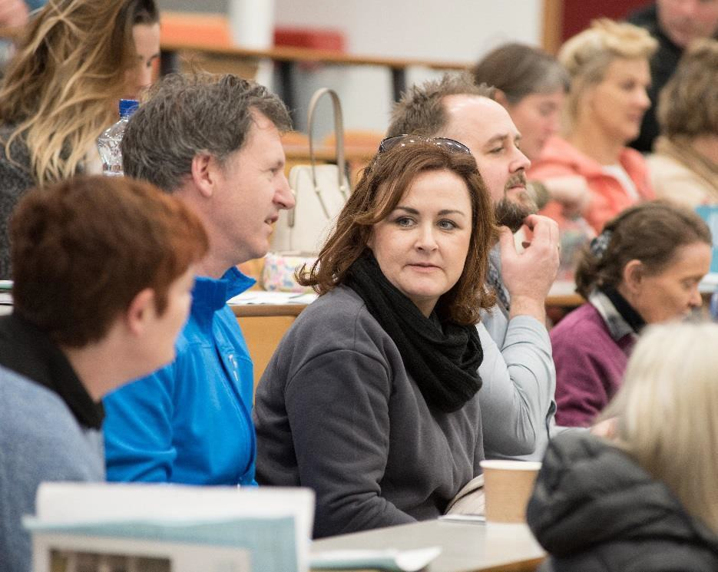

CERTIFICATE IN PSYCHOLOGY

Level 7 (20 ECTS)

This Certificate level course is designed to provide participants with the opportunity to develop an understanding of psychology and to explore its relevance to the individual, family, community and society. The course aims to introduce participants to the main psychological theories and examine their contribution to the development of the discipline.

WHO IS THIS QUALIFICATION FOR?
This course is aimed at people who would like a comprehensive introduction to the subject discipline of Psychology at university level.

OVERVIEW
Module 1 Introduction to Psychology and Study Skills; Overview of what psychology consists of, its history and study skills.

Module 2 The Biological Basis of Behaviour; Most behaviour is rooted in our biology; this module considers the role of the brain in sleep, sensation and perception.

Module 3 Learning and Feeling: This module focuses on how we learn, remember and experience emotions.

Module 4 Personality: This module reviews the most important theories of personality, and how personality is assessed under each of these theories.

Module 5 The Development of the Individual: This module considers the early development of the child from conception through to thought, language and moral development.

Module 6 Introduction to Social Psychology: Key areas in social psychology such as social perception, attitudes and prejudice will be explored in this module.

Module 7 Introduction to Abnormal Psychology: This module introduces students to the diagnosis, classification and treatment models in abnormal behaviour.

Module 8 Introduction to Social Research Methodology: An introduction to the main techniques involved in social research.

COURSE STRUCTURE:
The duration of the course is 100 hours. Students will attend 1 evening per week for a 3 hour facilitated workshop/tutorial. Students will also attend 3/4 Saturdays over the duration of the course.

COVID 19 CHANGES:________________________________________________
Given the current situation with the Covid 19 pandemic we hope to be able to run the courses as closely as possible to the way we have always run them. This being the case we are looking at the university guidelines for face to face classrooms and this means having small classes in large class rooms in order for us to observe physical distancing rules. However, we will need to be flexible in our approach and therefore we are also preparing for Blended delivery of courses. This will mean that depending on the advice from the government regarding tightening or loosening the control measures of lockdown we might have to switch to Microsoft TEAMS, Video or Moodle classes at short notice. As a consequence people who are thinking of applying for our certificate courses for 2022-2023 will need access to a PC or Laptop to take part in distance learning. We will do our utmost to give you the best learning experience that circumstances allow and hope to be able to continue with our preferred face to face classroom based teaching for as long as possible and it is safe to do so.

DATES, VENUES AND FEES for 2021-2022
Cork College of Commerce Start Date: Tuesday 4th Oct. 6.00-9.30pm
Scoil Mhuire Clane: Start Date Tuesday 4th Oct 7.00-10.00pm
Vita House Roscommon: Start Date Mondays Oct 7.00-.10 00pm
Pobalscoil Neasáin, School Lane, Baldoyle Start Tuesday 4th Oct 7.00-10.00pm

An Easy Payment Plan is available upon registration. Part time students who are on courses at levels 6 to 10 on the framework of qualifications may be eligible to for the Student Assistance Fund (SAF) to help with the associated costs of attending a university course such as Travel, Childcare, Utilities, Materials etc. You should first consult: SAF Guidelines to see if you qualify and then e-mail student.budget@mu.ie to make further enquiries.

CPD & PROGRESSION
The NUI Certificate in Psychology is a standalone qualification however when combined with the NUI Certificate in Training and Continuing Education (Train the Trainer Level 7) plus the Certificate Equality Studies (On Line) it forms part of the Diploma in Arts: Training and Development for Socially Inclusive Workplaces.

CONTACT US
Apply HERE: or to find out more about this and our other CPD courses please contact Kay Loughlin: 01 708 6062 or visit our website: https://www.maynoothuniversity.ie/adult-and-community- education/our-courses

