MU – UDL & U. Plus One

Title Clear Slide Design for Presentations

Brief description For some learners a slide filled with text in a font size smaller than 24 can be too hard to read or overwhelming, and for anyone with a visual impairment it is often not useful. Research shows that using high contrast design themes, with bullet points in a Sans Serif font of 24 point or more is easier for all students to follow. Providing relevant visuals – a symbol or picture that demonstrates or links meaningfully to the text enhances the learning experience not only for visual learners, but for all. In this way, the presentation augments the spoken word, rather than aims to replicate it.

Mapping to UDL Principles

Engagement | Representation | Action and Expression
Attractive and accessible visuals and related text. | Multiple means of representation text and visuals.  Providing related and relevant visuals for the key text information/data on slides.  High contrast to ensure ease of vision. | Supports students to process the information given in a logical manner.  Enables students to monitor the progress of the lesson and therefore their own understanding of the content.

Three ways this Plus One helps students

Students can

- enjoy multiple modes of delivery of information
- access the key information with fewer visual barriers
- more easily navigate between the spoken lecture and the presentation.

Key considerations for enactment

Risk Low

Time At the design and planning stage ensuring ‘cleanliness’ of slides

Technology PowerPoint (ppt)

The THRIVES model is a useful guide for the creation of ppt slides and other resources.

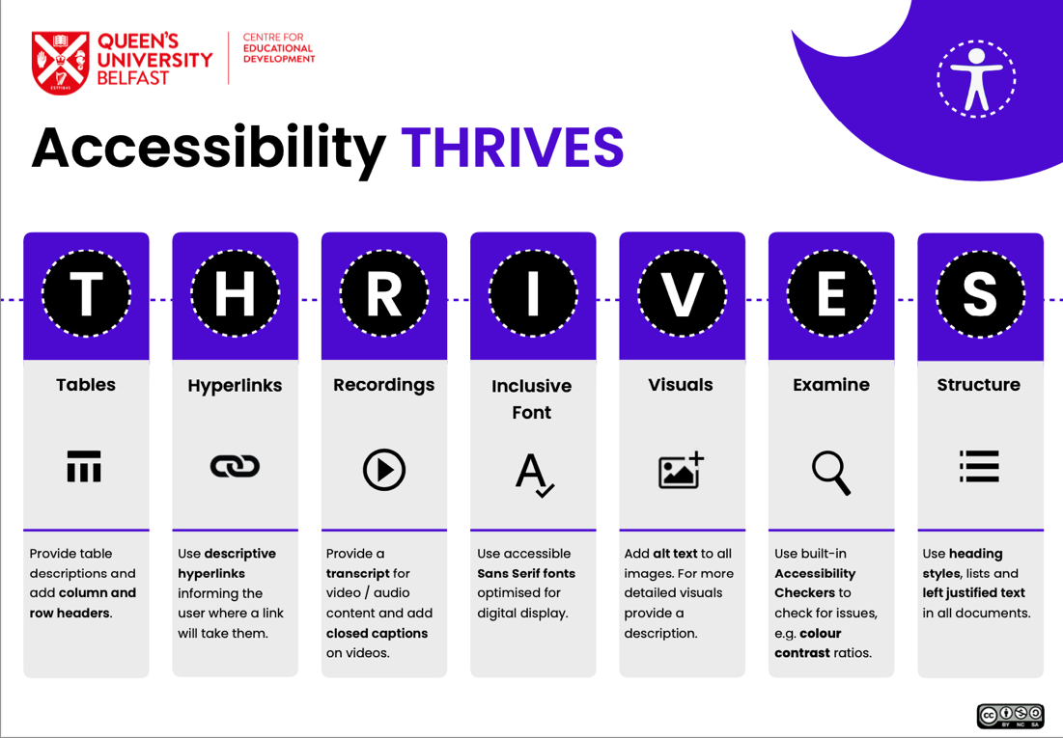

References

Queens University Belfast (n.d.) Accessibility Thrives. Shared under CC BY-NC-SA Accessible at: https://blogs.qub.ac.uk/digitaldevelopment/wp-content/uploads/sites/270/2018/06/QUB-Accessibility-THRIVES.pdf

Further information

See CAST UDL Guidelines and Maynooth University Plus One resources.

How to cite this document

Maynooth University UDL Teaching and Learning Fellows (2024). ‘Plus One – Clear Slide Design for Presentations’, Maynooth: Centre for Teaching and Learning, Maynooth University.

CC BY-NC-SA: This license allows reusers to distribute, remix, adapt, and build upon the material in any medium or format for noncommercial purposes only, and only so long as attribution is given to the creator. If you remix, adapt, or build upon the material, you must license the modified material under identical terms.

