Level 7 Certificate in Directing for Theatre

Maynooth University (Department of Adult and Community Education)

INTRODUCTION
The Certificate in Directing for Theatre is a Level 7 course. It is a practical course taught by Irish professional directors. It focuses on methods, tips and techniques, application of theory, and practice. This course is aimed at the following potential students:
- Mature students (21 years on 1st January) who wish to train for the theatre industry in Ireland and who would like to be prepared for further study in the field of directing;
- Those who wish to explore the field to discover if they wish to make a career in it. In this sense the Certificate serves as a skills-based training course for new directors;
- Those in the amateur, youth theatre and community theatre sectors who wish to formalise their experience into specific training, acquire accreditation and gain additional skills by doing so;
- Those who are emerging directors in fringe and professional theatre and who wish to gain specific skills and to acquire accreditation;
- Teachers and education workers who would like to train in directing in order to stage productions with students.

COURSE AIMS
- To introduce students to fundamental skills of directing for theatre
- To develop emerging directors’ confidence in their ability to stage a production

CONTENT
- Introduction to Stanislavski
- Introduction to Viewpoints
- Actioning and working with text
- Devising new material for performance
- Introduction to Physical Composition
- Introduction to Movement Theory
- Site-Specific and Site-Responsive Theatre
- Making theatre with young people
- Introduction to Directing Theatre-of-the-Oppressed
- Physical Comedy
- Directing Shakespeare – an introduction
- Introducing verbatim theatre and other styles of theatre-making
- Rehearsal techniques

From 1st May 2024 APPLY https://v2.pac.ie/institute/19

ADMISSION REQUIREMENTS
Participants must be 21 years on 1st January 2024 and have the academic capacity to complete a course at university level. Assistance is available free on campus with academic writing, library use, and assignment support. They must also have the capacity to direct a performance during the course of the year and, therefore, access to at least one performer is necessary.

.

REGISTRATION
This course requires a minimum number of students to have applied to do it before it can proceed. Once it begins, students then have to register as Maynooth University students and pay the course fee. Questions to do with application and registration are dealt with by the Department of Adult and Community Education. Contact:
- Kay Loughlin, Executive Assistant of Continuing Education on kay.loughlin@mu.ie or by phone on 01 7086062, or
- Derek Barter, Academic Coordinator of Continuing Education at derek.barter@mu.ie or by phone on 01 7083948
Registered students have access to Maynooth University library and the range of services available to Maynooth University students, and to national student discounts where available.

ASSESSMENT REQUIREMENTS

1. Students keep a Learning Journal in which they record and critically reflect on their learning, brought about by this course. They write an essay based on this Journal and submit the essay. For those who prefer other media, the ‘essay’ may also be submitted as a short film or audio documentary.

2. Directing Project – each student will be expected to direct a piece of theatre that is more than 30 minutes long. There is no upper time limit. This is filmed by the student and the film submitted. This can be privately produced (no public attendance) and it can be a performance for one performer. Or it can be a public show (possibly necessitating hiring a venue, acquiring rights to perform, marketing and insuring the show etc). It may be devised, scripted, collated or movement-based. However, it may not be a dance performance or opera (although it may have elements of these in it). Please note: the responsibility for doing this assignment is the students own. The university does not provide performers, or venues, or scheduling etc.

3. Directors’ Log – this is a written (or recorded) documentation of your process of staging the play, and it should also contain your reflection on the experience.

It is important to note that Department of Adult and Community Education Regulations prohibit a student from being awarded a grade/mark or a certificate if they:
  - do not attend at least 85% of the course
  - do not submit all assignments
  - do not pass each assignment.

ASSISTANCE
It is not possible for the course to provide assistance with casting, venue hire, or staging productions required as part of the assignments. We will provide advice, information and in-class support as part of the teaching and learning of the programme. Students should make provision to stage, and film their work themselves (in the way one would research and write an essay oneself). This means students should be able to find a performer or performers for their directing project. It helps if the student is a member of a drama group, has access to actors, or can work with a youth theatre. However, not being in this position is by no means a major barrier to participation: if the student wishes, the project does not need to be staged for the public, but can be mounted privately, using friends and collaborators, and filmed.

The filming quality does not need to be professional. The assessor simply needs to see the full range of the stage/performing area, clearly hear the dialogue, and see the performers’ expressions and actions.

Assistance is available on campus for essay writing and assignment support: https://www.maynoothuniversity.ie/centre-teaching-and-learning/writing-centre and registered students obtain student cards and access to the university’s library: https://www.maynoothuniversity.ie/library

COURSE DURATION
100 hours part-time over one year, on two Saturdays per month, from September 2024 to May 2025, excluding holidays in December. Class begins at 10.00am and runs to 5.00pm (with a break of 1 hour for lunch at 1.00pm, and coffee breaks in the morning and afternoon).

FEE €1400. This course is a Level 7 Certificate with 20 ECTS credits. Fees are set by the university.

VENUE Room 133, (The Drama Room) in the School of Education (pictured below), North Campus, Maynooth University, County Kildare. https://www.maynoothuniversity.ie/
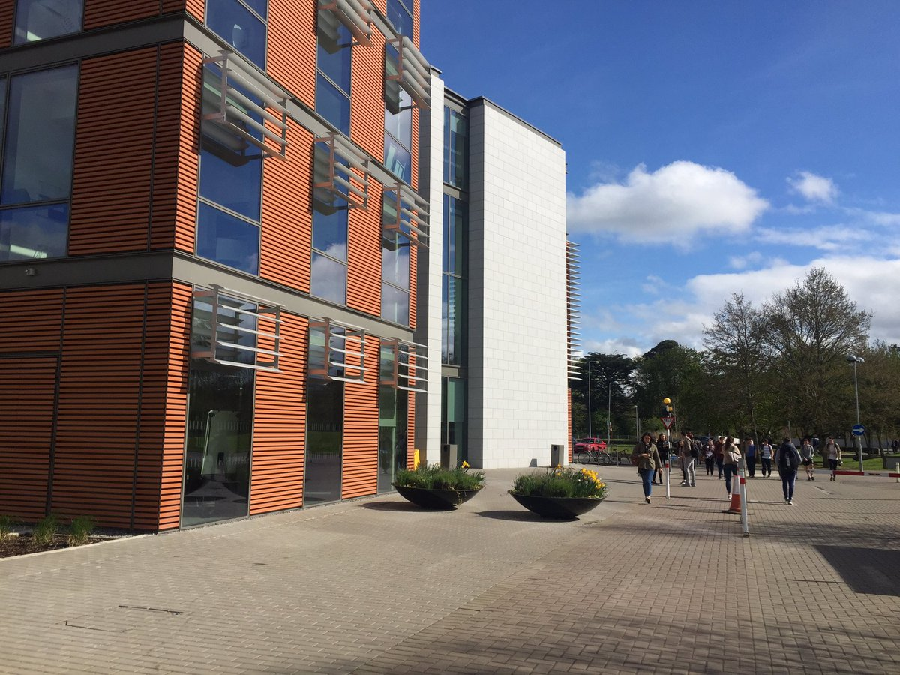

CONTACT

- For information to do with application form, registration, fees, library registration and all university-related queries, please contact Kay Loughlin kay.loughlin@mu.ie or Dr Derek Barter derek.barter@mu.ie

- For information to do with the course content, tutors, assignments and rationale etc, please contact Peter Hussey, the Course Coordinator at peter.hussey@mu.ie

WEBSITES
https://www.maynoothuniversity.ie/adult-and-community-education
www.crookedhouse.ie
www.cornexchange.ie
http://www.theperformancecorporation.com/
http://www.anuproductions.ie/2016/
https://www.youtube.com/playlist?list=PL494AA606A3F8B076 – National Theatre UK directing videos

TESTIMONIALS

“The Directing for Theatre course is very wide-ranging and covers a wide variety of directing styles. Each time I come from a class I feel I have gained a huge amount of new techniques. I came to this course as someone who works in the amateur drama world purely for the love of it. Up to now, I have relied entirely on 40 + years of experience and instinct when either directing or acting in a production. This year I took the decision to look at getting some qualifications in the field.
One of the most important things I have learned on this course is that we have at all times to protect our actors, especially emotionally. With the help and guidance of Peter Hussey and my classmates, I feel I will be able to negotiate this very difficult territory.’
Miriam O’Brien, student 2017-2018

“Brilliantly designed and practical course offering specific expert learning and shared experience of the role of directors in theatre-making. Highly recommend it and very enjoyable. So much so that many of the graduates who are mature students are keen for a follow on enhanced programme of learning with modules to Level 8 from Maynooth and delivered part-time also please. Do this course if you'd like to further your studies as a professional theatre-maker and skilled director.”
Mary Elizabeth Sheehan, student 2017 - 2018

“This is a fantastic course. Very practical and interesting. I thoroughly enjoyed it and learned so much from Peter and great team of guest lecturers.”
Mary Blake, student 2017 – 2018

“I really enjoyed this course, would highly recommend.”
Alison Martin, student 2015-2016

“Really enjoyed the course. Highly recommend it.”
Joe Bergin, Student 2017 – 2018

“Best training I ever had.”

Fiona de Faoite, Student 2009 - 2010

