Maynooth University Teaching Awards  2021-2022  Initial Submission Form | 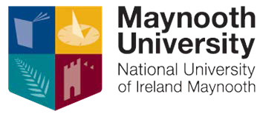

Congratulations on your nomination for a Maynooth University Teaching Award. The next stage requires you to submit a one-page outline of your approach to teaching and how it makes a marked impact on student learning and engagement.

You should review the criteria provided on the Maynooth University Teaching Awards Information and Guidelines document as an indicator of how the Awards Committee will evaluate submissions.

Individual Name or Team Names:
Department:

Please add your outline to the following page (please note that this should be a maximum of one page of text):

