

The History Department cordially invites you to the launch of

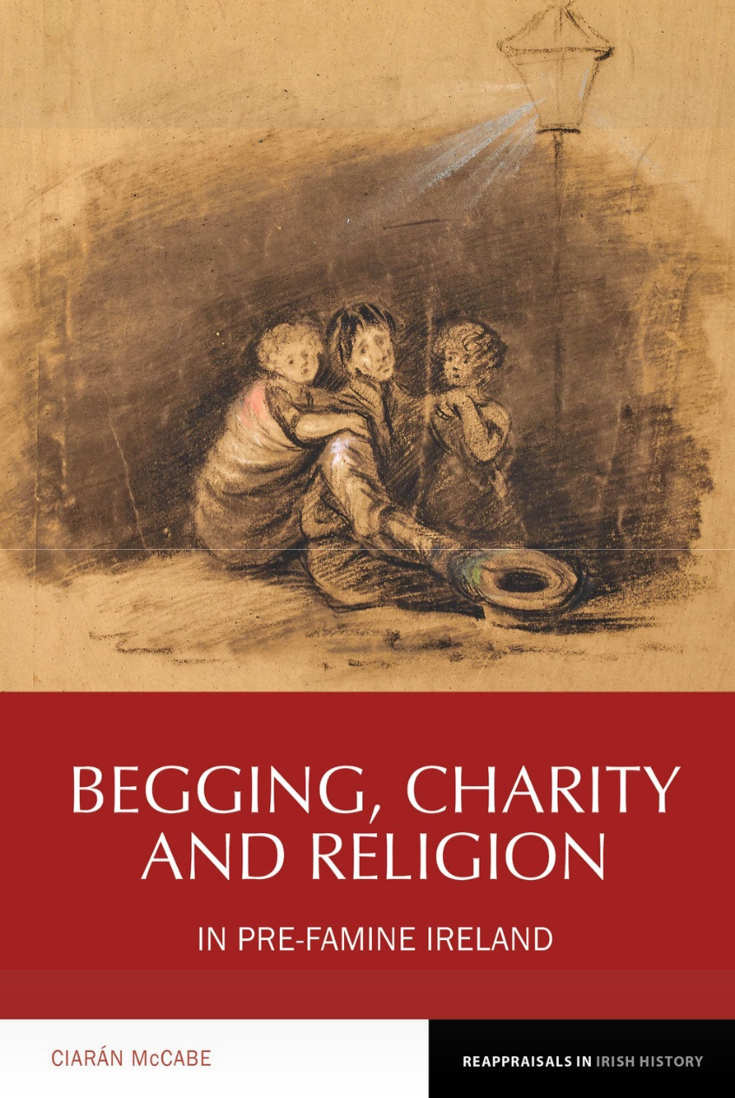

# Begging, Charity and Religion in

***Pre-Famine Ireland***

by

Dr Ciarán McCabe

**at 6.45pm Thursday 14 February 2019** in Iontas Building, North Campus, Maynooth University,

Maynooth, Co. Kildare

Professor Marian Lyons (MU) will speak RSVP: [history.department@mu.ie](mailto:history.department@mu.ie)



**A special launch price will apply**