National University of Ireland, Maynooth
DEPARTMENT OF HISTORY

FLYERS FOR OPTIONAL MODULES

II ARTS SEMESTER 2 2017-18

PLEASE NOTE

Flyers provide information supplementary to that available in module descriptors, which may be viewed on the university database at www.maynoothuniversity.ie/courses.

Students are expected to consult both flyers and module descriptors in advance of registration.

national university of ireland, maynooth
department of history
second arts, 2017-18

Second Semester
Module Co-ordinator  DR JONATHAN WRIGHT | Module code  HY 217 | Credits  2.5

Module title

READING MODULE 2B

Module content
This module requires students to read one or more assigned books/articles and to present an analytical report.

A list of approved titles will be provided on the relevant Moodle site early in the semester.

Upon successful completion of the module, students should be able to compose an analytical report based on assigned reading.

Form of assessment

2,500 word essay to be submitted by Tuesday, 8 May 2018

Special requirements (e.g., field trips inc. cost; special sessions; books)

None

national university of ireland, maynooth
department of history
second arts, 2017-18
Second Semester
Lecturer  DR ALISON FITZGERALD | Module code HY233 | Credits  5 | Lecture hours per week  Two
Module title:

PICTURING THE RENAISSANCE
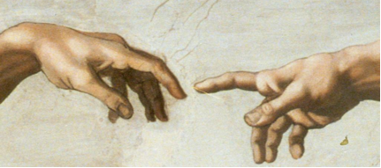

Module Content:
This elective examines European visual culture during the Renassance period. It explores the production and consumption of art, the role of politics and patronage in shaping the art market, and the evolution of style from the ‘rebirth’ of interest in the ancient world to the visual sophistication of the High Renaissance. Though focusing primarily on painting, it also considers other media including sculpture, print and decorative arts, and investigates issues such as the use of art in both public and private spaces, artist-patron relationships and the techniques used in the production of sacred and secular art.
No previous knowledge of the History of Art is required.

Assessment:
In-class assessment: 30%
Essay (3500 words) 70%
Deadline: Tuesday, 8 May 2018
Module conditions apply. See relevant descriptor at www.maynoothuniversity.ie/courses.

Special requirements (e.g., field trips inc. cost; special sessions; books):
The number of students admitted to this module is limited to 25.
There may be one site visit with this module, which would take place on a Friday afternoon, replacing the usual seminar times. This will be confirmed at the outset of the course.
national university of ireland, maynooth
department of history
second arts, 2017-18

Second Semester
Lecturer  TO BE CONFIRMED | Module code HY 247 | Credits  5 | Lecture hours per week  Two

Module title
Early modern Europe elective
THE IBERIAN INQUISITIONS

MODULE CONTENT
The inquisitions founded in Spain and Portugal in the late fifteenth and early sixteenth centuries were both instruments of ideological control and agents of the state-building. This module outlines the political and religious origins of the inquisitions. It describes how they functioned and in what ways they contributed to the political enterprises of the Spanish and Portuguese monarchs. As well as looking at their treatment of conversos, moriscos and alumbrados, their role in processing foreigners, especially those from the British Isles will be examined.

Module Aim
Students completing this module will have a sound understanding of the historical debates concerning the origins and aims of the Iberian inquisition. They will also have an appreciation of how the Inquisitions worked as instruments of state and how they compared to other early modern institutions. Through work on primary and secondary sources they will develop their Spanish language skills and their confidence in dealing with early modern palaeography.
Assessment

In-class presentation (max. 1000 words) 20%
Analysis of primary and/or secondary source (max. 1,000 words) 20%
Essay (max. 3,000 words) on topic approved by module leader: 60%
Deadline for submission of essay is Tuesday, 8 May 2018
Module conditions apply. See relevant descriptor at www.maynoothuniversity.ie/courses.

Special requirements (e.g., field trips inc. cost; special sessions; books)
Required text Helen Rawlings The Spanish Inquisition (London, 2006)
Recommended text: Francisco Bethencourt, The Inquisition: a global history, 1478-1834
national university of ireland, maynooth
department of history
second arts, 2017-18
Second Semester
Lecturer  DR DAVID LEDERER | Module code HY 249 | Credits  5 | Lecture hours per week  Two

Module title
THE HISTORY OF SUICIDE: A GLOBAL OUTLOOK

Module content

Before 1993, suicide was still a crime in Ireland. Commenting on the release of the report of the National Task Force on Suicide five years later, Mr Brian Cowen T.D., then Minister for Health and Children, declared:
In order to tackle this growing tragedy in our society it is essential that a clear, systematic approach aimed at the prevention of suicide and suicidal behaviour is put in place.
But is it? Certainly, Cowen’s statement reflects an historic shift in attitudes toward suicide. Self-murder was long prosecuted as a heinous crime in the Christian West until it ultimately became stigmatized as mental illness, a call for help or an inexplicable social tragedy. However, across the centuries and throughout cultures, choosing death is perceived differently. Some cultures deny the very existence of self-harm, while others glorify self-sacrifice. In classical antiquity, taking a Roman death meant defending one’s virtue. In the samurai Bushido code, seppuku was a defiant act, re-defined by young Japanese pilots coerced into serving as kamikaze. In Western misconceptions of India, the dark legend of the Sati still overshadows the pervasive practice of purification through self-starvation. Today, in the Middle East, martyrdom is the political hallmark of the Palestinian Intifada. Since Emile Durkheim first published his Le Suicide (1897), sociologists and medical professionals have argued that voluntary death is a universal and soluble problem. More recently, cultural historians have taken an interest in the subject with some rather surprising results.

Module aim
The purpose of this module is to examine orthodox preconceptions about suicide from a variety of perspectives and, in a broader sense, to provide participants with the critical skills to historically contextualize social behavior.

Requirements: The course consists of lectures, assigned readings from the course text (Georges Minois, The History of Suicide), films, and guest lectures.

Form of assessment
Grades are based on short assignments (40%) and a final essay of approximately 3,000 words (60%).
Essay deadline: Tuesday, 8 May 2018
Module conditions apply. See relevant module descriptor at www.nuim.ie/courses.
national university of ireland, maynooth
department of history
second arts, 2017-18

Second Semester
Lecturer:  PROFESSOR RAYMOND GILLESPIE | Module code HY256 | Credits  5 | Lecture hours per week  Two
Module title:

EARLY MODERN IRELAND ELECTIVE

Module content

Ireland over the course of the seventeenth century witnessed much social turmoil and political unrest. Thus, this module will investigate the implementation of English Common Law in Ireland, the expansion of royal power, the reorganization of Irish society and the consequences of these changes. By investigating the turbulent politics of the period, we will have a keyhole through which we can focus on other key issues such as the expansion of print, migration, Ireland and the wider world, the nobility, urban and rural communities as well as popular revolts, religious beliefs, and material culture. The main framework of the course will be chronological, examining roughly a decade per week and considering how the events of that decade shed light on the ideas and social values that lie behind those developments. We will also consider some of the institutional underpinnings of these ideas such as the parish, manorial courts and the courts of law and what they had to contribute to political culture. Each decade will also throw up particular problems, such as the role of honour, patronage and moral authority, for consideration. A contemporary political author, such as Sir John Davies, Geoffrey Keating, Richard Bellings and John Lynch and the author of A light to the blind, will also be attached to each decade. Similarly we will consider some the insights provided by literary activity into political culture. Your final essay should be a more detailed examination of these texts that we will glance at briefly in class.

Form of assessment
Essay, 3,000 words (65%), due on Tuesday, 8 May 2018
In-class test based on documents examined over the course (35%).
Module conditions apply. See relevant descriptor at www.maynoothuniversity.ie/courses.

Special requirements (e.g. field trips incl. cost; special sessions; books)
None
national university of ireland, maynooth
department of history
Second arts, 2017-18
Second Semester
Lecturer  DR JONATHAN WRIGHT | Module code HY 272 | Credits  5 | Lecture hours per week  Two

Module title
MODERN BRITISH ELECTIVE
SLAVERY AND ANTI-SLAVERY IN THE BRITISH WORLD, c. 1750-1833
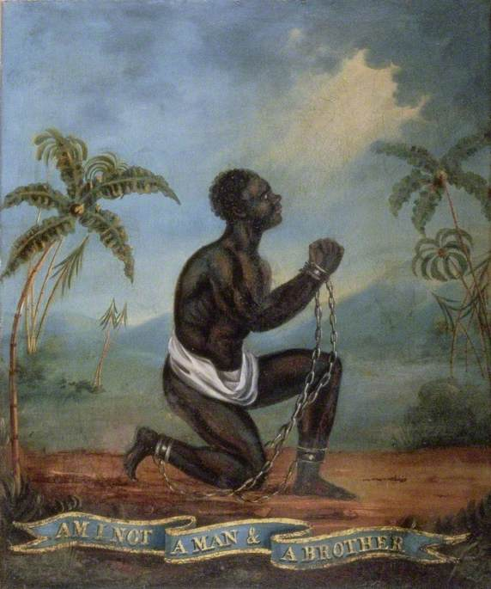
Module content
In 1562 John Hawkins, cousin of Sir Francis Drake, captured 300 Africans from Sierra Leone, inaugurating British involvement in ‘the largest forced migration in history’ – the Atlantic slave-trade. By the mid-eighteenth century, Britain had emerged as a leading player in this trade and slavery had become central to the Atlantic economy. Transported to the British colonies in America and the West Indies, slaves produced sugar, tobacco and, above all, profits. Vast fortunes were made on the back of the slave trade and transatlantic slavery impacted British society in multiple ways. Yet, by 1807 the lucrative trade in slaves had been prohibited by parliament, and while slavery persisted as an institution in the British colonies, this too was abolished in 1833.

This module will provide students with an opportunity to explore the character of British involvement in the slave trade, and to examine the reasons for its abolition and its long–term consequences. Situating Britain within the wider ‘Atlantic world’, the module will stress that slavery was not just something that happened ‘over there’, in the colonies, but something that had real and tangible consequences ‘at home’ in Britain. To this end, a range of themes will be explored, including: the middle passage and the triangular trade; plantation life and slave rebellion; the growth of Britain’s slave-trading ports; consumption and the cultural impact of slavery; the culture of abolition; and the continuing legacy of Britain’s involvement in the slave trade.

Module aim
Having completed the module, students will have engaged with key historiographical debates relating both to slavery and the ‘Atlantic World’, and will have developed a nuanced understanding of the multifaceted nature of British involvement in the slave trade and an appreciation of its on-going significance. In addition they will have used a range of traditional and online archival resources, and will have been given an opportunity to develop their written and oral presentation skills by completing in-class presentations and written assignments.

Assessment: Group presentation 20%
Analysis of primary source (c. 1,500 words) 20%
Essay (c. 2,500-3,000 words) on a topic approved by the lecturer: 60%
Deadline for submission of essay: Tuesday, 8 May 2018
Module conditions apply. See relevant descriptor at www.maynoothuniversity.ie/courses.
national university of ireland, maynooth
department of history
second arts, 2017-18

Second Semester
Lecturer  DR IDA MILNE | Module code HY 273 | Credits  5

Module title
Modern Ireland history: RECORDING HISTORY
Days and times  Two hours per week | Venue  TBC

Module Content
This project-based module introduces oral history as a research method for historians. Students will conduct individual and group research on an aspect of the history of work in Ireland since 1945. Surveying and doing original research on the history of work will enable students to review the modernisation of Irish society, through the lens of working lives. They will gain an understanding of impacts changes in education and technology make on the workplace. They will explore the topics of gender, class, health, religion and leisure in the workplace, and see how these change over time.
Students will gain theoretical and practical experience of oral history. They will learn about oral history’s strengths and weaknesses and enhance their understanding of the broader methodological issues posed by research in modern social history. They will learn interviewing and recording skills, and will learn how to professionally transcribe and archive interviews, important skills that can be employed in dissertation research and in the world beyond graduation. Team working skills will be developed through collaborative research on their chosen topic. These skills will also be fine-tuned via team presentations ‘pitching’ a programming idea (based on the oral history interviews) to broadcasters and radio documentary makers.
This course offers the opportunity to learn several transferrable skills which could be used in other contexts, adding to the analytical and research skills the undergraduate student learns from their degree course. An increased capacity for independent learning (through the conduct of one-to-one interviews and the transcription and analysis of those interviews) is an important aspect of this module. Oral presentational skills will be developed through reporting on work-in-progress in seminars and in the group presentation. The module will, therefore, significantly enhance many of the skills related to the types of employment to which history graduates aspire, i.e. team-working, interpersonal skills, the ability to synthesize large bodies of information, and the compilation of written reports. The nature of the research carried out and the responsibilities and demands involved in working with our interviewees also ensure that this module will enhance students’ appreciation of ethical issues and best practice in carrying out responsible research.

Form of assessment
Interview transcript 20%; Individual critical commentary: c. 1,500 words 20%
Essay (c. 3,000 words) on approved topic: 50%
Group Presentation: pitching documentary ideas 10%
Module conditions apply. See relevant descriptor at www.maynoothuniversity.ie/courses
national university of ireland, maynooth
department of history
second arts, 2017-18

Second Semester
Lecturer | Module code HY 276 | Credits  5

Module title
GENDER AND HISTORY
Days and times  Two hours per week | Venue  TBC

Module Content
This module studies the concept of gender and history, examining historical studies of men and women in the nineteenth and twentieth centuries, as well as the theoretical literature that has drawn attention to the different roles men and women had in the modern period. The course covers some key issues in political, legislative and social history, from the education of women, to prostitution and homosexuality. We also cover the critical social movements of the period that revolved around gender – including the campaigns for women’s right to vote and own property on an equal basis in the nineteenth century, to the campaigns regarding equal pay, contraception and women’s legal status in the twentieth century. Issues of masculinity, femininity and gender norms are interrogated as they have been understood historically and contemporarily. Important writers of each period will be examined, giving students a chance to reflect on both primary and secondary sources relating to each theme.

The course as a whole examines how gendered ideologies that have changed over time and as part of this students will also examine the historiography of gender history as it has developed in the latter half of the twentieth century. Primarily, this course draws on Irish and British history as they were intertwined throughout the nineteenth and twentieth century.

Module Aim and Objectives:
Aim: This module’s aim is to enable students to understand, reflect on, and write critically on gender as a concept in modern history.

Module Structure:
This module will be lecture-based

Form of assessment
One-hour exam at end of semester 50%
Continuous assessment: 50%
In-class test based on primary source analysis mid-semester
1,500 word essay, due for submission in second last week of lectures
Module conditions apply. See relevant descriptor at www.maynoothuniversity.ie/courses
national university of ireland, maynooth
department of history
second arts, 2017-18

Second Semester
Lecturer  PROFESSOR FILIPE RIBEIRO DE MENESES | Module code HY 291 | Credits  5 | Lecture hours per week  Two

Spain and Portugal: twentieth century
FROM DICTATORSHIP TO DEMOCRACY IN THE IBERIAN PENINSULA: TRANSFORMATIONS AND CURRENT CHALLENGES, 1926 TO THE PRESENT

Module Content
This module studies the origins, nature and demise of the Franco and Salazar dictatorships, outwardly similar and largely concurrent, but in fact different in their aims, outlook and methods. Special attention is paid to the personalities of the two dictators, as well as the legacy of Spain’s Civil War and Portugal’s colonial Empire as elements of differentiation between the two regimes. The creation of democratic regimes in Spain and Portugal in the mid-1970s in the aftermath of prolonged dictatorships and the current political and economic challenges are also considered in detail.

Module Aim and Objectives:
Aim:
- To enable students to understand, reflect on, and write critically on the history of contemporary Spain and Portugal, two countries whose recent trajectory sets them apart from other Western European states.

Objectives:
- To all students to gain a solid understanding of contemporary Spanish and Portuguese history, becoming acquainted with the relevant historiographies.
- To build on the students’ ability to work with primary documents.
- To develop students’ ability to write in an academic fashion.

Module Structure:
This module will be lecture-based, although time will be allotted for the discussion of primary and secondary sources.

Form of assessment
Assessment will consist of:
- A review of an academic article (1,000 words);
- An analysis of a primary document (1,000 words);
- A final essay (3,000 words).
Deadline for submission of essay: Tuesday, 8 May 2018
Module conditions apply. See relevant descriptor at www.maynoothuniversity.ie/courses

department of history
second arts, 2017-18

Second Semester
Lecturer  DR DAVID MURPHY | Module code HY 384 | Credits  5 | Lecture hours per week  Two

Module title:
THE GREAT WAR, 1914-18: a military history

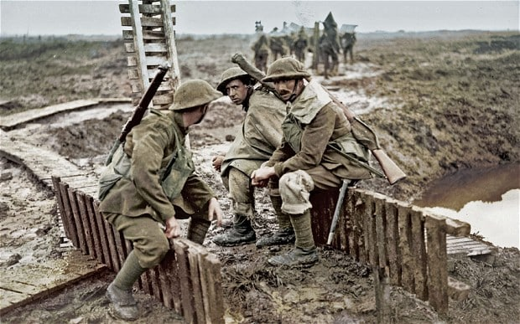

Content:
This elective will focus on the origins and conduct of the “Great War” of 1914-18. Lectures will examine the campaign on the Western Front and also events in the Eastern and Middle Eastern theatres. There will be some reference to the impact of the war on Ireland and the effect of the global conflict on the civilian population of the belligerent powers. The naval and airpower aspects of this war will also be discussed. There will be some discussion of developments in military technology and “legacy issues” during the inter-war period.

Objectives:
This elective will provide participating students with an understanding of the political, strategic and operational history of the “Great War” of 1914-18.

Core Texts:
Hew Stachan (editor), The Oxford Illustrated History of the First World War (New edition, 2014)
John Keegan, The First World War (1998)
BBC TV Series, The Great War (available as a boxed set through the MU library)
Assessment
Two-hour examination at end of semester.
national university of ireland, maynooth
department of history
second arts, 2017-18

Second Semester
Lecturers  DR COLMÁN ETCHINGHAM | Module code SG252 | Credits  5 | Lecture hours per week  Two

Module title
IRELAND ENCOUNTERS SCANDINAVIA: THE VIKING AGE

Module content
The period 795-1169 in Irish history is one in which Ireland's encounter with the Viking-age Scandinavians had far reaching effects on Ireland's history — political, military, economic, social and cultural. This module seeks to look at that encounter from two perspectives. On the one hand the impact of the Vikings on Ireland itself will be outlined. On the other, the Viking experience in Scandinavia, the North Atlantic, Continental Europe and Britain will be explored for the light it sheds on the Vikings in Ireland.

Form of assessment

Continuous assessment: 50%

One-hour end-of-semester examination: 50%

Special requirements (e.g. field trips inc. costs, special sessions)

Please note that SG252 is timetabled by Sean-Ghaeilge and may clash with core
lectures in other subjects.

