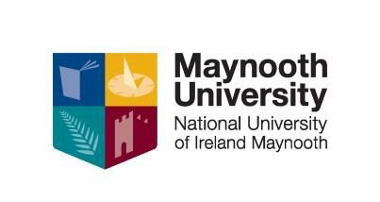

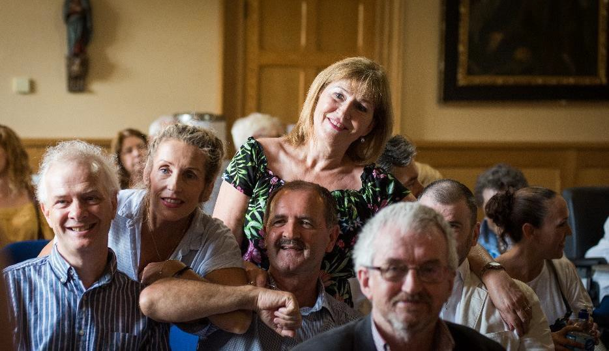
NUI CERTIFCATE CREATIVE WRITING FOR PUBLICAT ION

OVERVIEW
This course will give participants a practical grounding in the writing of fiction and creative non- fiction for publication. The course allows students to work with professional writers who will act in a mentoring capacity. The practical emphasis will help students to progress towards producing work of publishable standard and marketing it. The development of critiquing and editing skills are essential for creative writing. Student interaction and engagement with each other’s work guided by experienced writers and lecturers is aimed to provide a supportive environment for the development of these skills. One of the most valuable aspects of participation in this course for the aspiring writer is to have their work critiqued and work- shopped regularly by professional novelists, playwrights and publishing industry experts.

WHO IS THIS QUALIFICATION FOR?
It is said that every one of us has a novel inside. Whether or not this is the case this course in creative writing will give you the opportunity to find out for yourself. This course is designed to allow students: to develop creative writing skills; to cultivate a disciplined approach to writing; to develop students’ skills in critically assessing their own and others’ work; to provide an understanding of the economics and structure of the publishing industry.

COURSE STRUCTURE?
The NUI Cert. in Creative Writing for Publication will be held on our Maynooth Campus Thursday Evening 6.30-9.30pm. The duration of the course is 100 hours. Students will attend 1 evening per week for a 3 hour facilitated workshop/tutorial. Students will also attend 3/4 Saturdays over the duration of the course.

COVID 19 CHANGES____________________________________________
Given the current situation with the Covid 19 pandemic we hope to be able to run the courses as closely as possible to the way we have always run them. This being the case we are looking at the university guidelines for face to face classrooms and this means having small classes in large class rooms in order for us to observe physical distancing rules. However, we will need to be flexible in our approach and therefore we are also preparing for Blended delivery of courses. This will mean that depending on the advice from the government regarding tightening or loosening the control measures of lockdown we might have to switch to Teams, Video or Moodle classes at short notice. As a consequence, people who are thinking of applying for our certificate courses for 2022-2023 will need access to a PC or Laptop to take part in distance learning. We will do our utmost to give you the best learning experience that circumstances allow and hope to be able to continue with our preferred face to face classroom based teaching for as long as possible and as it is safe to do so.

DATES, VENUES AND FEES
This course will commence on Thursday 6th October 2022 on campus in Maynooth University.

An Easy Payment Plan is available from the Fees Office upon registration.

Part time students who are on courses at levels 6 to 10 on the framework of qualifications may be eligible to for the Student Assistance Fund (SAF) to help with the associated costs of attending a university course such as Travel, Childcare, Utilities, Materials etc. You should first consult: SAF Guidelines to see if you qualify and then e-mail student.budget@mu.ie to make further enquiries.

CONTACT US
Apply HERE: or to find out more please contact Kay Loughlin on 01 708 6062 or e-mail: kay.loughlin@mu.ie or visit our website: https://www.maynoothuniversity.ie/adult-and- community-education/our-courses

