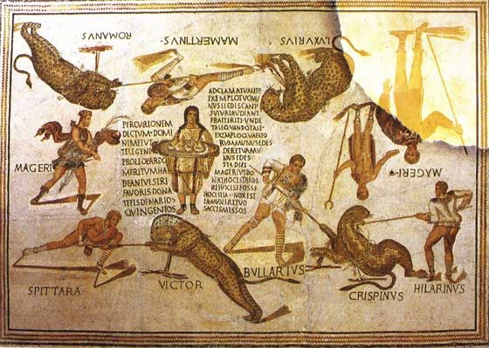
Classical Association of Ireland

Latin Summer School 2024

Join us this summer for a full immersion in all things Roman!

Beginners welcome!
Join in person (Trinity College Dublin) or on Zoom

- Three classes per day for two weeks
- Minimum age: 12
- Course fee: €200

17 - 28 JUNE 2024
Information and registration:
cosetta.cadau@mu.ie

Follow us on

@ClassicalAssoc1

