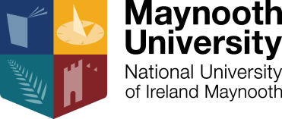

NEW PHD OPPORTUNITY AT THE HAMILTON INSTITUTE, MAYNOOTH UNIVERSITY, KILDARE, IRELAND

The Hamilton Institute at Maynooth University are seeking to recruit a new funded PhD studentship in Professor Andrew Parnell’s research group in the area of Bayesian machine learning. The Hamilton Institute is dedicated to providing a bridge between mathematics and its applications in ICT, biology and other disciplines. Founded in 2001 with support from Science Foundation Ireland, the Hamilton Institute has been internationally recognized for its work across communication networks, machine learning, mathematical biology and fundamental mathematics.

The student will join a team of researchers working in areas including: Bayesian additive regression trees, multivariate factor models, anomaly detection, and closed-loop control theory. Company partners include IBM and Clavis Insight. Application areas include bioinformatics, climate change and 3D printing.

All applicants must have
- Relevant 2:1 degree (or higher) in Mathematics, Engineering, Physics, Computer Science, Statistics, Machine Learning, Data Science, or similar qualification
- Ability to code in one or more of Matlab, C, R or Python
- Strong linear algebra and calculus skills
- Excellent written and verbal communication and presentation skills in English

The studentships are for 48 months and include a tax free stipend of €18,500 p.a. and the payment of academic fees up to a maximum of €5,500 per annum, as well as a computer and travel allowance.

Application Procedure: send a curriculum vitae and a cover letter to hamilton@mu.ie with PHD Parnell in the subject.

Closing Date: 31st October 2019

Interview: Interviews will be held in November 2019

