Application of Raman microspectroscopy and digital holographic microscopy to cytology
B.M. Hennelly¹⁻³, S. Barton¹, X. Fan¹, J.J.Healy⁴, D. Yue¹, Y. Qin¹, L. Kerr¹
¹Department of Electronic Engineering, Maynooth University, Maynooth, Kildare, Ireland
²Department of Computer Science, Maynooth University, Maynooth, Kildare, Ireland
³Hamilton Institute, Maynooth University, Maynooth, Kildare, Ireland
⁴Department of Electronic Engineering, University College Dublin, Belfield, Dublin 4, Ireland

Raman spectroscopy combined with multivariate statistical methods enables classification of biological materials based on subtle differences in biochemical composition [1]. Raman spectroscopy can be integrated with a commercial microscope to record spectra from a tissue or cell sample with high spatial resolution, as illustrated in Fig. 1. Digital holography [2,3], or more generally quantitative phase imaging, can also be integrated with a microscope to obtain information on cell morphology, as well as providing enhancement in terms of depth of focus and aberration compensation; a typical set-up for digital holographic microscopy is shown in Fig. 2. Here, we present some recent work on the application of these techniques for clinical cytology, with a particular emphasis on urine cytology. Examination of voided urine for exfoliated cells has high sensitivity in high grade tumours, but low sensitivity in low grade tumours. We hope to improve the sensitivity of this approach using a combination of Raman and digital holographic microscopy.

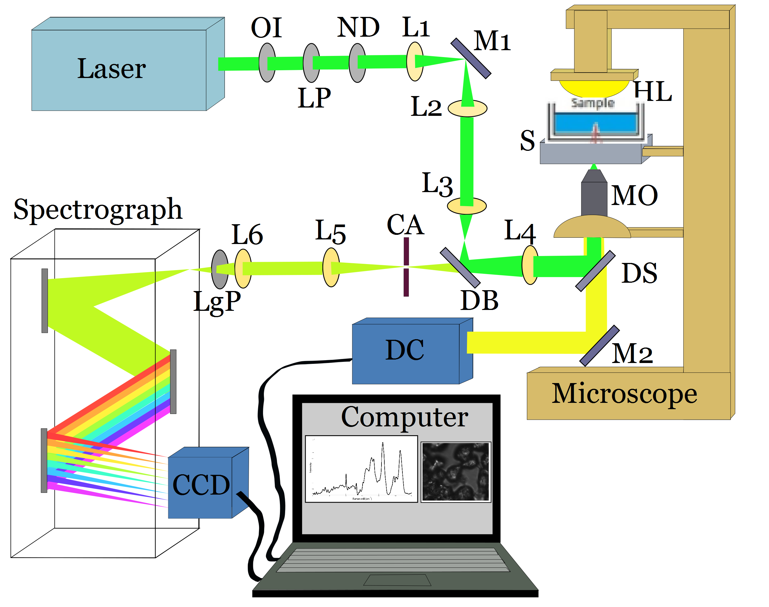
Fig. 2 Optical setup of off-axis transmission digital holography microscopy.
Fig. 1 A typical system for confocal Raman micro-spectroscopy, in which the same MO delivers the source laser and collects the Raman spectrum

REFERENCES
[1] Kerr, L.T., Lynn, T.M., Cullen, I.M., Daly, P.J., Shah, N., O'Dea, S., Malkin, A. and Hennelly, B.M., 2016. Methodologies for bladder cancer detection with Raman based urine cytology. Analytical Methods, 8(25), pp.4991-5000.
[2] Marquet, P., Rappaz, B., Magistretti, P.J., Cuche, E., Emery, Y., Colomb, T. and Depeursinge, C., 2005. Digital holographic microscopy: a noninvasive contrast imaging technique allowing quantitative visualization of living cells with subwavelength axial accuracy. Optics letters, 30(5), pp.468-470 (2005)
[3] Fan, X., Healy, J.J. and Hennelly, B.M., 2017. Investigation of sparsity metrics for autofocusing in digital holographic microscopy. Optical Engineering, 56(5), pp.053112-053112

Biography

Bryan Hennelly received his BE in electronic engineering, from University College Dublin in 2001 and his PhD, also from UCD, in 2005 in the areas of optical engineering and computational imaging. This was followed by a postdoctoral fellowship supported by the Irish Research Council for Science Engineering and Technology in 2005 at the Department of Computer Science in Maynooth University. In 2008 he was awarded funding as Principal investigator of an FP7 research STREP project named Real 3D which involved the development of digital holographic systems for three dimensional microscopy and real world displays. In 2012 he joined the biomedical engineering research group in the Department of Electronic and Electrical Engineering in Maynooth University and established a biophotonics laboratory. In the same year he was awarded a Science Foundation Ireland Starter Researcher Grant for the development of Raman micro-spectroscopy based diagnostic systems, and in 2015 he was awarded a Career Development Award by SFI. His current research focuses on the development of optoelectronic microscopy systems for application in the area of clinical pathology. He is currently working on automated microscopy/spectroscopy systems for diagnosing early stage bladder cancer from urine samples using a combination of image processing algorithms and, holographic microscopy and Raman micro-spectroscopy. He has authored over 100 publications and has numerous collaborators in industry, academia and in HSE institutions.

More information about his research and publications can be found at the links below.
http://scholar.google.com/citations?user=UwRiAWAAAAAJ&hl=en
http://biomed.eeng.nuim.ie/
http://www.linkedin.com/pub/bryan-hennelly/24/a24/321#

