Ollscoil Mhá Nuad
Maynooth University

Doc Version 16/08/2020

August Supplemental Registration Process
A guide for students

Please note that you should refer to the official Exams Office timetable for exam dates and times once this has been made available on our website.
Overview
Irrespective of the method of assessment, if you wish to amend the mark you were given during the year, you must register for the Autumn supplementals.
Who may apply
All undergraduates and post graduates whose courses finish in May.
Restrictions
- There may be modules that are universally not offered in Autumn and the next available sitting will be in the next academic year
- There may be modules which have an Autumn supplemental assessment but an individual student may not be permitted to register having failed to complete certain requirements of the course throughout the year
Information relating to both scenarios is readily available from course finder. When you search for a module the information is available under ‘Repeat Options’

How to apply
- You may self register for Autumn supplementals if you have obtained a Restricted Deficit, Restricted Compensation, Restricted: No Progression or a Not Progress as your overall mark.
You do this by going to the Student Web portal and logging in
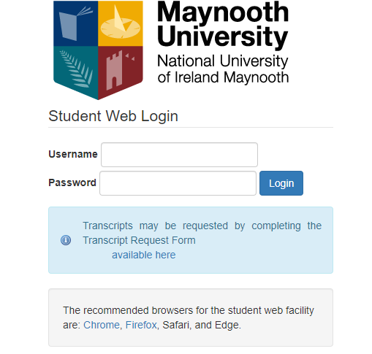
You then open “Supplementary Registration” and select “Supplemental Registration”
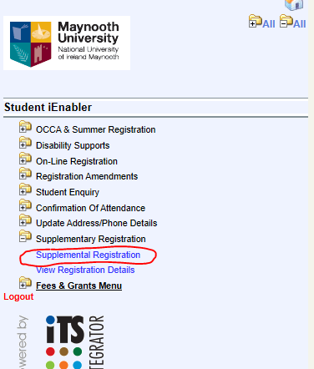
You will then be brought to a screen where you can select the modules you wish to register for.
Please be advised that it is the responsibility of you as a student to ensure that you have selected the correct modules that will allow you to proceed into your next year of study. There are numerous places to seek advice on this such as your Department or the Exam Results Information Centre which runs annually.
When you select Supplemental Registration modules may appear under 3 possible headings as shown below depending on your results and any restrictions:
In order to register please tick beside the appropriate module.

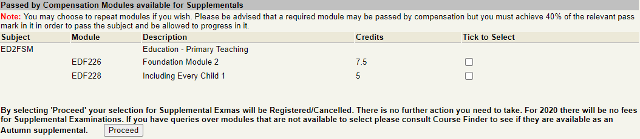
Please note modules listed in ‘Modules not Passed or Passed by Compensation where Supplemental are not Permitted’ cannot be selected. Please refer to restrictions above for further information on these.

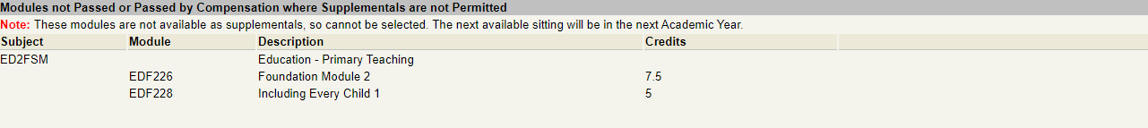

Once the modules have been selected click Proceed and the screen below will appear with confirmation of the modules you have selected.
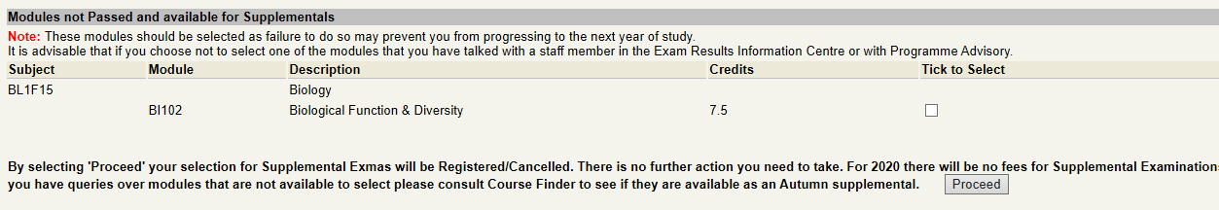
They will be listed as Autumn as shown below:
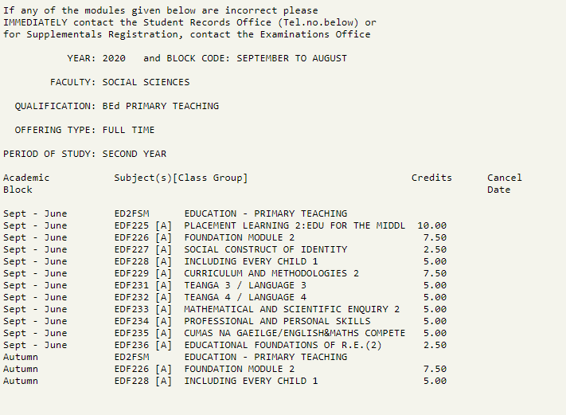

Please note you can make amendments to your registration online but only before the deadline date for registration as outlined on the Examinations Office website.

  - Cancelling a module
Once you have registered to a module it will appear on the registration screen as shown below and will be available to cancel:
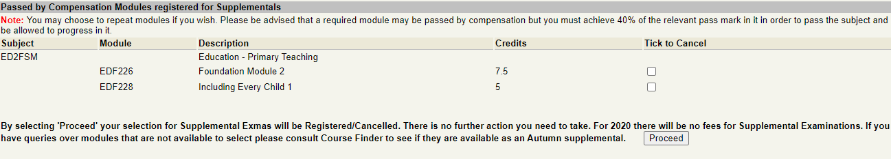
If you wish to cancel a module you have already registered for you may do so here by selecting the module under ‘Tick to Cancel’ and click on Proceed
The registration screen will appear again but this time with a cancellation date as highlighted below:
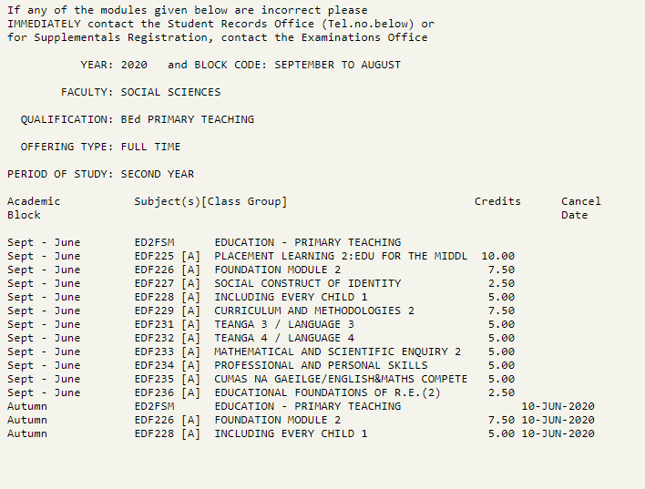
The Fee payment process is separate to the registration process and any fees queries will need to be directed to the Fees Office.

- If you wish to repeat to improve your mark on a module you have already passed, or are doing an undergraduate degree that does not finish until September, i.e. has a work placement etc over the summer, then you will need to email the Examinations Office (exams.office@mu.ie) in order to register. Please note that if you are in final year and have been awarded your degree there are additional forms that you will need to fill out in order to register for Autumn. The Examinations Office website has all the information you need.

