Core Expenses – Staff Manual
Approver 2 (HOD) Manual

Table of Contents

Details | Page Number
Login | 2
Approve/Reject Expense Claim | 3

Login
Navigate to the Core Portal Login page by copying below to your browser:
https://www.maynoothuniversity.ie/ess
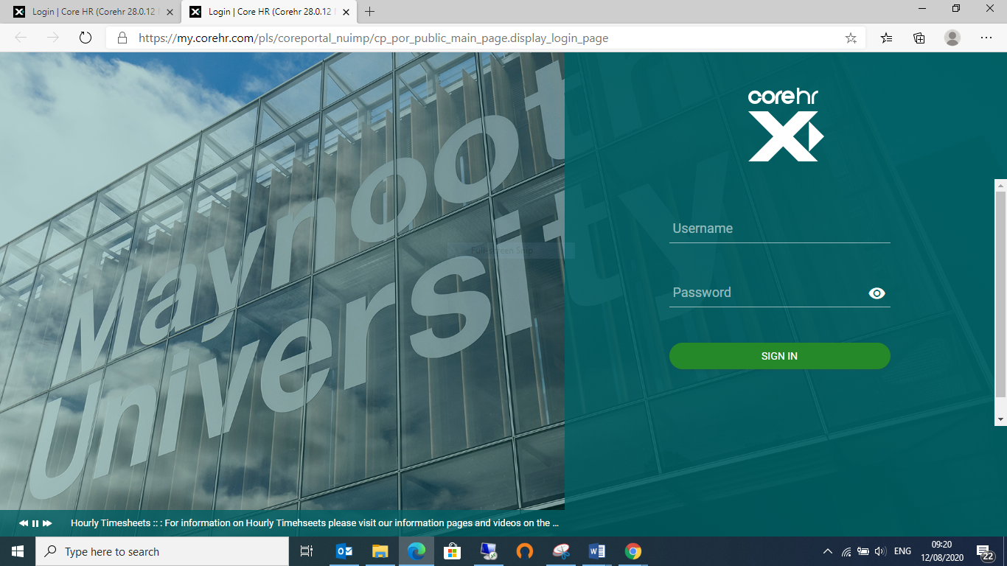

To login, enter your system username and password in the corresponding fields and press enter on your keyboard or click on Sign in

Click on “Manager Dashboard” – Top of screen on Left
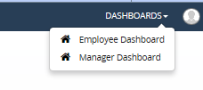

The following will appear for approval

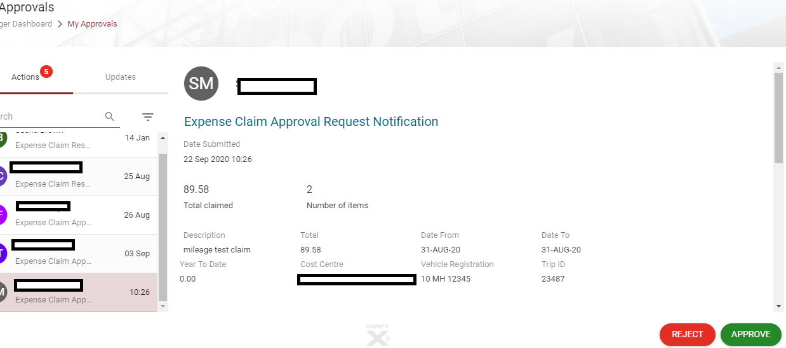

You can view each expense item individually to by clicking on the 3 dots
Here you can;
- View details
- View receipts
- Add approver notes

Once you are happy with all of the details you can scroll down to;

‘have you viewed the receipts’

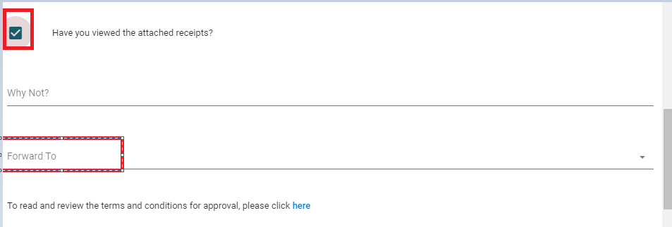
Tick – Have you viewed the attached receipts?
Then hit approve or reject if you are not satisfied. If you hit reject you must provide a reason for the claimant and the claim will go back to them.

