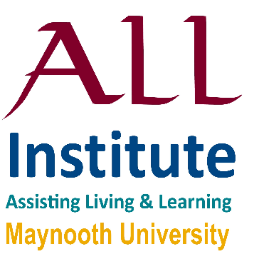

Sustainable Assistive Technology Provision

- Sharing Perspectives

11.00-1.00

Thursday 17th October ‘19,

Hume Boardroom, 3rd Floor,

John Hume Building,

Maynooth University

**All Welcome**

Light refreshments served

3rd Symposium

|  |
| --- |
| for & by ALL Institute  **11:00 – Welcome and Review** |
|  |
| **11:10 - Keynote Presentation:**  Dr. Rosie Gowran - Occupational Therapy  School of Allied Health, University of Limerick |
| **11:45 – Tea/ coffee**  **12:00 - Round Table Discussion:** |
| Prof. Mac MacLachlan – Psychology, Chair |
| Dr. Linzi Ryan – Design Innovation |
| Dr. Rudi Villing – Electronic Engineering t.b.c. |
| Dr. Rebecca Maguire – Psychology |
|  |
|  |

**ALL** Assisting Living & Learning